Chubby Gourmet’s E-Commerce Web Application

Project Documentation Submitted to the Faculty of the

School of Computing and Information Technologies

Asia Pacific College

In Partial Fulfillment of the Requirements for

Systems Analysis and Detailed Design for IT

MSYADD1

By

|  |  |
| --- | --- |
| Gianna Bernice R. Artajos | Marcus Philip L. Flores |
| John Rysal C. Rosel | Lester Dave M. Salazar |

ASIA PACIFIC COLLEGE

Approval Sheet

Chubby Gourmet’s E-Commerce Web Application

Prepared and submitted by

|  |  |
| --- | --- |
| Gianna Bernice R. Artajos | Marcus Philip L. Flores |
| John Rysal C. Rosel | Lester Dave M. Salazar |

In Partial Fulfillment of the Requirements for the Degree of

Bachelor of Science in Information Technology

Examined and Recommended for Acceptance and Approval for

Research/Capstone Presentation

___________________________

Ms. Jo Anne M. de la Cuesta, Adviser

Panelists

___________________________

<Name>, Chairperson

|  |  |
| --- | --- |
| ___________________________ | ___________________________ |
| Ms. Roselle Wednesday L. Gardon, Panel Member | Dr. Manuel L. Calimlim Jr., Panel Member |

Acceptance and Approved in Partial Fulfillment of the Requirements for the Degree of

Bachelor of Science in Information Technology

___________________________

Rhea-Luz R. Valbuena

Executive Director

School of Computing and Information Technologies

Table of Contents

List of Figures i

List of Tables iii

I. Introduction 1

1.1 Project Context 1

1.2 Statement of the Problem 2

1.3 Objectives 2

1.4 Significance of the Project 3

1.5 Scope and Limitations 4

II. Review of Related Literature / Systems 6

2.1 Related Literature 6

2.2 Related System 9

2.3 Synthesis 12

III. Technical Background 13

3.1 Current System 13

3.1.1 List of Processes 13

3.1.2 SWOT Analysis 14

3.2 Proposed System 15

3.2.1 Software 15

3.2.2 Hardware 15

3.2.3 Network 16

3.2.4 Security 16

IV. Methodology 17

4.1 Requirements Analysis 17

4.1.1 Product Backlog / User Stories 17

4.1.2 Event Tables 18

4.1.3 Use Case Diagrams 19

4.1.4 Use Case Full Description 20

4.2 Gap Analysis 42

4.3 System Analysis and Design 43

4.3.1 Context Diagram 43

4.3.2 Data Flow Diagrams 44

4.3.3 Entity-Relationship Diagrams 48

4.3.4 Activity Diagrams 49

4.3.5 Object Diagrams 59

4.3.6 Class Diagrams 60

4.3.7 Sequence Diagrams 61

4.3.8 State Machine Diagram 69

4.3.9 Deployment Diagram 72

4.3.10 Package Diagram 73

4.3.11 Component Diagram 74

4.3.12 Data Dictionary 75

V. Results and Discussion 78

5.1 Release Plan 78

5.2 Prototype 78

5.3 Use Classes and Characteristics 87

VI. Conclusion 88

References 89

Appendices 91

Appendix A: Project Vision 91

Appendix B: Product Roadmap 92

Appendix C: Teams Meeting 93

Appendix D: Minutes of the Meeting 94

# List of Figures

Fig. 1. GoDaddy domain price [11] 8

Fig. 2. Hostinger web hosting plan [12] 8

Fig. 3. Casa Moriones Web Application [14] 9

Fig. 4. Jess & Pat's Online Store [15] 10

Fig. 5. The Daily Knead Online Store [7] 10

Fig. 6. GrabFood PH Web Application [16] 11

Fig. 7. Food Panda Web Application [17] 11

Fig. 8. Use Case Diagram 19

Fig. 9. Current System - Context Flow Diagram 43

Fig. 10. Proposed System - Context Flow Diagram 43

Fig. 11. Current System - Level 0 44

Fig. 12. Proposed System - Level 0 45

Fig. 13. Manage Product - Level 1 46

Fig. 14. Manage Order - Level 1 46

Fig. 15. Manage Inventory - Level 1 47

Fig. 16. Create Order - Level 1 47

Fig. 17. Entity-Relationship Diagram 48

Fig. 18. Manage Admin's Account (Login and Change Password) 49

Fig. 19. Manage Product 50

Fig. 20. Create product 50

Fig. 21. Update Product 51

Fig. 22. Delete Product 51

Fig. 23. Manage Order 52

Fig. 24. Generate Report 52

Fig. 25. Manage Inventory 53

Fig. 26. Create Inventory 53

Fig. 27. Update Inventory 53

Fig. 28. Delete Inventory 54

Fig. 29. Login to store 55

Fig. 30. Create Order 56

Fig. 31. Select Mode of Payment 57

Fig. 32. Track Order 58

Fig. 33. Object Diagram 59

Fig. 34. Class Diagram 60

Fig. 35. Manage Admin's Account 61

Fig. 36. Login to store 62

Fig. 37. Manage Product 63

Fig. 38. View Product 64

Fig. 39. Create Order (Part 1) 64

Fig. 40. Create Order (Part 2) 65

Fig. 41. Manage Order 66

Fig. 42. Track Order 67

Fig. 43. Manage Inventory 67

Fig. 44. Generate Report 68

Fig. 45. Change Password 69

Fig. 46. Customer Account 69

Fig. 47. Create Order 70

Fig. 48. Manage Order 70

Fig. 49. Order Status 71

Fig. 50. Deployment Diagram 72

Fig. 51. Package Diagram 73

Fig. 52. Component Diagram 74

Fig. 53. Landing Page 78

Fig. 54. Popular Dishes Section 79

Fig. 55. About Section 79

Fig. 56. Catering Schedule Section 80

Fig. 57. Frequently Asked Questions Page 80

Fig. 58. Menu and Cart Page 81

Fig. 59. Order and Payment form 82

Fig. 60. “Thank you” page 83

Fig. 61. Admin Dashboard Login 84

Fig. 62. Account Management Page 84

Fig. 63. Order Management Page 85

Fig. 64. Product Management Page 85

Fig. 65. Inventory Management Page 86

Fig. 66. Analytics Page 87

# List of Tables

TABLE I LIST OF PROCESSES OF THE CURRENT SYSTEM 13

TABLE II HARDWARE REQUIREMENT [18] 15

TABLE III NETWORK REQUIREMENT [18] 16

Table IV USER STORIES 17

Table V EVENT TABLE 18

Table VI GAP ANALYSIS 42

Table VII PRODUCTS 72

Table VIII CATEGORY 72

Table IX ORDERS 72

Table X CITY 73

Table XI ORDER STATUS 73

Table XII CHUBBY GOURMET ACCOUNT 73

Table XIII INVENTORY 73

Table XIV PAYMENT 73

Table XV REPORTS 74

Table XVI USER CLASSES AND CHARACTERISITCS 84

Table XVII PROJECT VISION 88

Table XVIII PRODUCT ROADMAP 89

# Introduction

This section of the paper discusses the needs of the local food business, Chubby Gourmet [1]. It will also discuss the context of who the client is, the problems they are currently facing, what objectives are set out for the project, and the significance of the project that will support them in solidifying the project.

As the pandemic ensues on a global scale and in our country, it brings forth problems such as the temporary shutdown of establishments for the safety of the public, limited entry for certain barangays and subdivisions, and a curfew for residents who wish to go out.  Due to the discontinuation of establishments, the rise of small to medium businesses became prominent across the country, with a whopping 850, 127 businesses in 2020 being established according to the Department of Trade and Industry [2], for the local consumer to access and buy their products.

The closing of establishments causes fewer consumers willing to go out to buy, henceforth the demand for the digitalization of ordering products rises to greater heights for both consumers and sellers. Applications such as GrabFoods, or the use of online delivery services, pull these larger businesses forward into success as they adapt to the situation the pandemic has caused. On the other hand, small-to-medium businesses find it more difficult to stand out amongst the sea of other small-to-medium businesses advertising on free platforms such as Facebook groups and the lack of staff they may have on hand.

## Project Context

Through this COVID-19 pandemic, consumer behavior has changed dramatically in recent years [3]. Many customers became used to internet food delivery services to avoid stepping outside because of lockdowns and business closures. Many businesses adapt to the ongoing crisis by shifting to online business platforms like the Facebook marketplace, Facebook pages, and Instagram shops [3].

**The Challenges**

Chubby Gourmet [1] is a local food business that was founded by Priscilla Mariano, in April 2020 in Laguna Bel-Air, Sta. Rosa Laguna. They are currently a small enterprise that does all its operations in the comfort of its own home. They do not have any other established branches whatsoever, because they are in a proximity delivery kind of business. Their products vary from plates of pasta to chicken to desserts such as cookies, and they plan to offer catering services soon to their customers.

A small business, like Chubby Gourmet, does not have any extra staff members, for all the processes are done in the business are handled by Miss Mariano herself. Chubby Gourmet uses a manual process of writing down orders on a whiteboard and writes down crucial information such as income, ingredients for planned dishes, and their current inventory using pen and paper.

Currently, the business's main platform is Facebook, where they market their products, post what is and is not available, and contact their customers using the Facebook Messenger application.

Although setting up a Facebook page is reliable for marketing your brand, Chubby Gourmet would still have to do time-consuming tasks such as manually updating their customers on what is and is not available on their menu.

## Statement of the Problem

Local food businesses that operate using Facebook pages and the marketplace face problems when it comes to managing their market, for they have limited resources and staff which would bring time-consuming processes [4]. Chubby Gourmet faces the same issues other local businesses may face, and the developers were able to narrow down the following general and specific problems of the business.

**General Problem**

Chubby Gourmet has difficulty managing its current process due to being a   
one-woman job in the business.

**Specific Problem**

They also experience:

1. Trouble in organizing the orders from Facebook Messenger. It takes at least 30-40 minutes, according to Chubby Gourmet, to manually list down all orders received from customers using a whiteboard. They have an average of 6 customers a day, and all orders are for big groups.
2. Difficulty in keeping track of their inventory because they need to manually write down using pen and paper all the details regarding ingredients needed for future grocery trips, and their current inventory.
3. The need to endure time-consuming tasks such as frequently answering the same set of questions such as bank details, availability of a product, and delivery details, due to being the only person in the business.

## Objectives

After discovering and analyzing the problems that are being faced by Chubby Gourmet, the developers tend to help solve these problems with the help of the following objectives:

**General Objective**

Improve process problems found within Chubby Gourmet by implementing an   
E-commerce web application.

**Specific Objectives**

1. Organize customer orders faster by 80%, which contains details such as personal information, orders, and transaction details [5].
2. Digitize 100% of the inventory management allowing an easier way of tracking (add, update, delete) current inventory [6].
3. Display answers to common queries from customers with two (2) to three (3) clicks, so that Chubby Gourmet could spend less time answering questions every day [7].

## Significance of the Project

Throughout the development, there will be a handful of groups that will benefit from our action plan. Whether it be monetary or economic, the main purpose is to inspire a positive change towards these groups. The groups of individuals who will benefit from the project are the following:

**Chubby Gourmet**

The focus of the project is Chubby Gourmet, which needs help in recording its order information through a web application, instead of recording its data manually. There are a sizeable number of owners that do not have a proper platform to display their products and services, and the developers believe that these businesses can be seen and be discovered more by the public if they decide to integrate a reliable web application into their business.

**Customers**

Hungry customers will always be present in the market at any given point and appealing by giving them a convenient way to order food is an absolute must in the food business industry. They would not ask for more if there is a responsive web application that allows them to visually interact with a restaurant they might have spotted on Facebook. The web application will also give the user a more focused and detailed overview of the selections and services the business has to offer.

**Decent Work and Economic Growth**

Helping small businesses can escalate to more positive attributes, for it could range into an increase in motivation for the workforce, economic boost, and improvement of the business overall. The project falls under one of the Sustainable Development Goals (SDG) of the United Nations, which is the eighth (8th) SDG, Decent Work and Economic Growth. As the project integrates convenience and automation for Chubby Gourmet it would encourage other small businesses to do the same and follow the new standard of   
e-commerce.

## Scope and Limitations

The development and deployment of the project will be done throughout the three assigned academic terms. The developers will only be creating a responsive web application. This means that when the user accesses the web application’s link through their mobile phone, the web application will have a mobile version ready for the customer The developers' knowledge in making web applications is limited but not bound to learn more during the development of the application.

The developers will also be co-working with Chubby Gourmet on the design elements  
(e.g., theme, logo, and product design) of the business. This means the developers would look and see what they can improve on the logo, color scheme, and themes surrounding the business. However, the developers will not be involved in arranging the products and services the business has to offer, as they agreed it is Chubby Gourmet’s role in the matter.

For the functionalities of the project, the developers plan to integrate the following features into the web application:

* **Product Management**

Chubby Gourmet will be able to add, edit, and delete a product to highlight its business. Products posted will be shown on the menu page where customers can order.

* **Product Management**

Chubby Gourmet can easily manage the newly placed products without the need of writing them using a pen and paper.

* **Inventory Management**

The admin dashboard will be equipped with inventory management where the owner of the business can easily update the inventory eliminating the need to write manually which is prone to human error.

* **Generation of Reports**

In terms of business growth, since data will be captured, reports can be generated on the admin dashboard like a popular dish of the month, and the location with the greatest number of orders. Also, monthly revenue will be displayed on the admin dashboard.

* **Shopping Cart**

The customers will have the opportunity to order in bulk with the use of the   
add-to-cart button. This will help them to order different items at once.

* **Checkout**

The checkout will show the selection of food that the customer has ordered. It will also allow them to confirm the delivery, inform them of their total, and attach proof of payment.

* **Payment**

The customer can choose between PayPal, Bank Transfer, or GCash.

* **Delivery Schedule**

Customers have the freedom to choose their preferred date of delivery, at least a day after the order placement.

* **Catering Schedule**

Chubby Gourmet plans to add catering to its services. The developers then suggested integrating a catering schedule so it can fulfill the goal of Chubby Gourmet.

* **Order Tracking**

The customer can track the status of their order via the My Orders tab wherein it also stores their past transactions.

# Review of Related Literature / Systems

Before developing Chubby Gourmet’s e-commerce web application, the developers need a concrete understanding of already fully developed e-commerce web applications to have an idea of what the system can be and what is in it for the business. To gain a better understanding of what responsive web applications the developers intend to develop, they did their research on similar projects in terms of purpose, significance, functionality, and features. Here are the following related literature and systems that coincide with the system from published websites and studies.

## Related Literature

**The Statistics of MSMEs During 2020**

According to the Department of Trade and Industry [2], there were at least 800,000 micro-businesses, and 90,000 small businesses established during the year 2020. In the five sectoral distributions made, the category Accommodations and Food Services Activities was the second-highest sector with 134,046 businesses that were established. The reason for these kinds of businesses was due to the lockdown order as the pandemic began. Of that 134,000 businesses, Chubby Gourmet is one of those businesses that was made amid the global predicament and adapted to the situation by setting up the online business it is now.

**Advantages and Disadvantages of E-Commerce**

According to Khan, A. [8], it can propel them forward tenfold with the numerous benefits it may bring. Whether it may be the convenience of online transactions, the accessibility of their market, the interaction it may bring for both the consumer and sellers with the use of feedback systems, and the substantial contribution it may have on the economy and the market from shifting to the traditional way of business to this   
format [8].

On the other hand, it may also bring disadvantages such as the consumer market that does not have access to the internet which drives customers off to other businesses or the confidentiality of the user’s data privacy [8].

The developers intend to use this article in the development of the project because they have now gained an understanding of how important this must be for Chubby Gourmet to shift its business in a new direction. For them, it would not be a hard shift in their business since they started with advertising and selling their products on Facebook, which already uses online transactions. The e-commerce web application will be an opportunity for them to have another social platform that can expand their business, and this technology will help them compete with other businesses in the market.

**Return of Investment (ROI) from E-commerce Application**

One important metric that a company should consider in a business is the Return of Investment (ROI) of their online shop, it shows what a business gets back from its investment on the platform. If the metric shows a positive ROI, the business makes a profit. However, if the business reflects a negative ROI, it means the business should adjust its marketing strategy or drop the said platform [9].

Chubby Gourmet, a micro-business, should track whether the proposed web application is profitable or not. This study will help Chubby Gourmet to track its ROI. With the use of basic E-commerce ROI calculation, the developers can calculate the possible ROI of Chubby Gourmet’s e-commerce web application in the first year once the system is released [10]. The numbers presented below came from a survey with Chubby Gourmet.

$revenue=(revenue per month)(no. of months per year)$ (1)

$$revenue=(20,000)(12)$$

$revenue=240,000$

Equation 1 shows that the approximate revenue for the year will be computed by multiplying the revenue per month, ₱240,000.00, by the number of months in a year, 12 months.

$operating expense=(\left(ingredients+electric bill+water+gas+hosting plan\right)\left(no. of months per year\right))+domain$ (2)

$$operating expense=(\left(2,583+3,400+600+1,000+99\right)\left(12\right))+260$$

$$operating expense=92,444$$

Equation 2 shows the computation for operating expenses for the year, and it will be computed by the summation of all monthly expenses such as ingredients, ₱2583.00, electric bill, ₱3,400.00, water, ₱600.00, gas, ₱1,000.00 and hosting plan, ₱99.00. Moreover, it will be multiplied by the number of months per year, 12 months, to get the approximate yearly operating expense. Lastly, the domain plan, ₱260.00, will be added since it is a yearly plan.

$investment=electric fryer+oven+mixer+stove$ (3)

$$investment=1,200+8,000+2,300+1,178$$

$$investment=12,678$$

Equation 3 shows that the approximate investment for the year will be computed by the summation of the electric fryer, ₱1,200.00, oven, ₱8,000.00, mixer, ₱2,300.00, and stove, ₱1,178.00.

$ROI=\left(\frac{revenue-operating expense}{investment}\right)x 100$ (4)

$$ROI=\left(\frac{240,000-92,444}{12,678}\right)x 100$$

$$ROI=1,163.87\%$$

Lastly, equation 4 shows the approximate ROI of Chubby Gourmet for the first (1st) year. It is computed by revenue, ₱240,000.00, less than operating expense, ₱92,444.00, and it will be divided by the investment, ₱12,678.00. To get the percentage, it will then be multiplied by 100.

With this equation, Chubby Gourmet will have an ROI of 1,163.87% for the first (1st) year once the e-commerce web application is deployed.

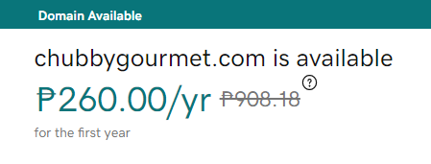

Fig. 1. GoDaddy domain price [11]



Fig. 2. Hostinger web hosting plan [12]

**Importance of Guest Checkout on an E-Commerce Application**

In the checkout process, some e-commerce offers faster transactions where users can order immediately as a guest; however, some of them require the user to register before checking out the order. For first-time customers, it would be difficult for them to entrust their personal information to a business given they have never shared their personal information to that web application before. Forcing customers to register before checking out can lead to the abandonment of 35% of e-commerce transaction, which does not bring a good look as it affects the credibility and customer satisfaction of the business [13].

In contrast, there are disadvantages in using guest checkout such as, customers cannot receive announcements about promotions and discounts and the inability to review a product [13]. However, the developers analyzed about the disadvantages which lead them to the decision of implementing a newsletter feature, for the announcement and ranking of products, so that customers will have an idea of what is the current best-selling product of the business.

The developers intend to use guest checkout to allow customers to order efficiently when in Chubby Gourmet’s e-commerce web application. Minimizing the number of clicks can prevent the abandonment of a transaction and with this, aims to achieve the general objective of the proposed system.

## Related System

**Casa Moriones**

Casa Moriones [14] is a catering company operating in Metro Manila and the CALABARZON area, specifically in Laguna. It offers a wide range of packages and services, from catering services to event planning and management. Customers and clients can choose from the variety of foods that they offer, including appetizers, entrees, and even desserts. It features the same services that Chubby Gourmet intends to add to its business such as online reservations, and package options.



Fig. 3. Casa Moriones Web Application [14]

**Jess & Pat’s Shipping Fee Method**

Jess & Pat’s [15] is a lifestyle and clothing brand that sells clothing and accessories of select Original Filipino Music artists that are stylish and youthful-looking merchandise. Jess & Pat’s uses the software *Shopify* which features the same shipping fee system that the developers intend to implement on Chubby Gourmet’s e-commerce web application. Jess & Pat`s shipping fee depends on the customer's location, wherein the shipping fee is cheaper when it is around Metro Manila, and a much more expensive shipping fee if the location is outside of Metro Manila.

Moreover, *Shopify* has a feature where customers can check out an item without logging in, which previously mentioned, the developers will also implement this feature to give the customers the same benefit such as fast processes and less hassle that Chubby Gourmet gets when handling the system.

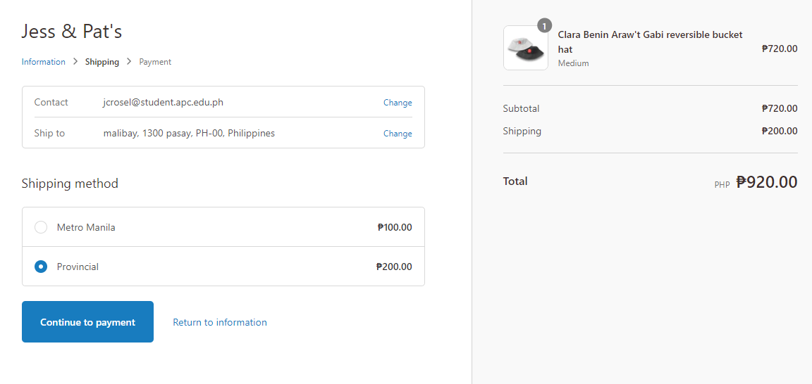

Fig. 4. Jess & Pat's Online Store [15]

**The Daily Knead**

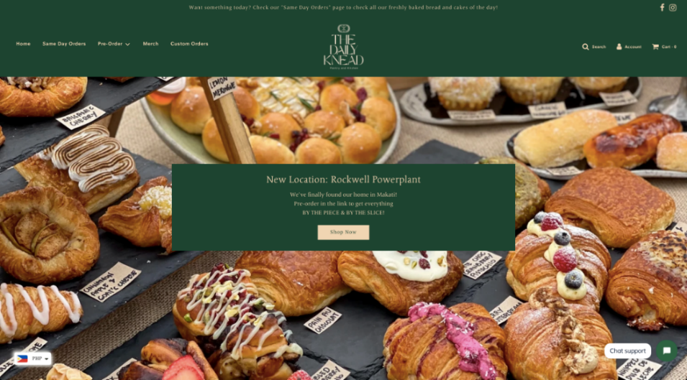The Daily Knead [7] is an e-commerce web application based in Parañaque, they sell handmade bread and pastry goods. This web application has an ordering system and e-commerce features. The same goes with Chubby Gourmet, the developers are planning to implement essential e-commerce features such as add-to-cart, transaction policy, mailing list, and the delivery schedule which includes the calendar and the shipping policy.

Fig. 5. The Daily Knead Online Store [7]

**GrabFood PH & Food Panda**

Grab Food [16] and Food Panda [17] are two separate but similar e-commerce web applications that offer a wide variety of restaurants and food services available for the user to order from. They are both the fastest-growing e-commerce enterprises in the Philippines, and both features the same components the developers intend to add to Chubby Gourmet’s web application. The features they plan to make use of that can be seen in GrabFood PH and Food Panda are features such as add to cart, check out, delivery date, and special instructions for the seller.

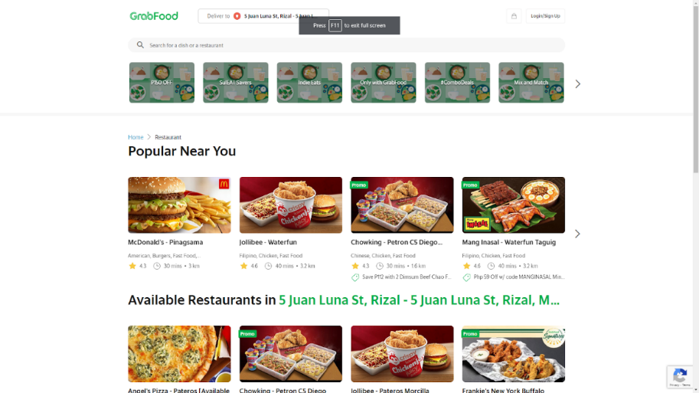

Fig. 6. GrabFood PH Web Application [16]

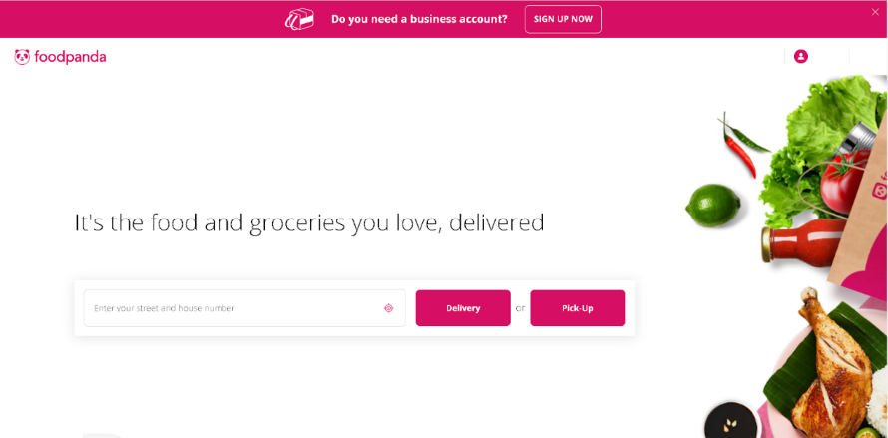

Fig. 7. Food Panda Web Application [17]

## Synthesis

The studies and systems mentioned in this chapter show the importance of the objectives that the developers wish to achieve. From the study about the current situation, Chubby Gourmet is, which is them being a micro-enterprise and has inefficient processes of manually writing it down, to similar web applications that fit the description of what they intend to do.

This chapter discussed the related studies that would help them gain a deeper understanding of Chubby Gourmet’s business and the related systems that the developers will be using as a reference once they start developing. The features mentioned will surely help successfully meet the requirements of Chubby Gourmet and establish a system that can help their business to be more efficient.

# Technical Background

This section of the paper discusses the current system being used by Chubby Gourmet. Specifically, this section will tackle the technical background of the current system, a list of processes, and a SWOT analysis.

## Current System

Currently, Chubby Gourmet uses Facebook Page and Groups to market its products. In terms of order collection, they use Facebook Messenger to reach out to their customers to process their orders. As for their backlog of orders, they manually write it out on a notepad for all the orders that were processed.

### List of Processes

TABLE I   
LIST OF PROCESSES OF THE CURRENT SYSTEM

|  |  |  |
| --- | --- | --- |
| Process ID | Process  Name | Process  Details |
| P001 | Market products using Facebook Page and Groups | * 1. CHUBBY GOURMET posts product details on the Facebook page. |
| P002 | Ordering System | 1. CUSTOMER sends order message through Facebook Messenger 2. CHUBBY GOURMET displays an automated reply containing an order form 3. CUSTOMERS send order information. 4. CHUBBY GOURMET displays payment information. 5. CUSTOMERS send proof of payment 6. CHUBBY GOURMET confirms order |
| P003 | Delivery System | 1. CHUBBY GOURMET delivers the orders using Lalamove |

Based on the interview with Chubby Gourmet, they use Facebook as their current system to market their product, interact with the customer, and organize the orders. The usual way of ordering products on Facebook starts with P001 wherein Chubby Gourmet posts its products to reach out to the audience.

On the other hand, P002 starts when a customer sees a product that they want to order by sending a message to the seller through Facebook Messenger. Second, Chubby Gourmet responds with an automated message which contains the order form that needs to be filled in by the customer. Once it is done, the customer should send the order information to process the delivery. Fourth, the payment works by sending the payment

information to the customer by using different means of online bank transactions. Fifth, the customer needs to send proof of payment before processing the order.

Lastly, Chubby Gourmet confirms the order and processes it right away. To conclude the process, P003 shows that Chubby Gourmet delivers the orders using Lalamove.

### 3.1.2 SWOT Analysis

After interviewing Chubby Gourmet and gaining information on the details of their business and how it functions, the developers produced a SWOT analysis to plot out the different areas of how the business is.

**Strengths**

* Socially active online business
  + - * Chubby Gourmet is very responsive to their customer’s concerns, and inquiries.
* It has its own branding identity
  + - * Chubby Gourmet already has its logo and branding
* Quality of product
  + - * Chubby Gourmet receives valuable feedback from its customers.
* The menu offers a wide range of options
  + - * They offer a variety of products that customers can choose from.

**Weaknesses**

* Deliveries are for specific areas only
  + - * Other customers may not be accommodated since delivery is only limited to certain areas.
* One-woman Job
  + - * All processes are done by one individual.
* Tedious order collection
  + - * The process of ordering through Messenger takes a lot of time.

**Opportunities**

* Client capitalizes on Facebook’s wide audience
  + - * They can be able to expand their business with the use of the platform’s accessibility.
* It has a thousand Facebook followers
  + - * The business has a high potential of getting its brand known and attracting more customers.
* Growing acceptance of ordering food online.
  + - * Regular Facebook customers would be more intrigued and inclined to order with the presence of another social media platform.

**Threats**

* Catering and party services are not available
  + - * Competitor businesses offer these kinds of services.
* No backup social media platform
  + - * They do not have any supporting social media platforms.
* Same type of business that operates using Facebook pages
  + - * Customers may choose other similar businesses that offer the same product and services.

## Proposed System

This subchapter will discuss the proposed solution in terms of software, hardware, network, and security that will be used for the final product.

### Software

The proposed system is a web application that will help Chubby Gourmet market its product and enhance the processing of orders, which benefits both the customer and Chubby Gourmet. With the use of an admin dashboard, Chubby Gourmet can post and update the products with ease. On the other hand, customers can easily check out their orders since payment options are already displayed on the web application wherein customers can send the payments through the bank account of the seller using a bank transfer.

The E-Commerce web application will be implemented using HTML/CSS, JavaScript, PHP, and MySQL. This means that the front-end development (page development, User Interface, and User Experience), all the way to the back end (content editing, product posting, and order processing) will be developed from scratch, and the developers will not be using any website builder during the whole duration of the development.

In terms of payment mode, PayPal will be used to accommodate credit/debit cards of the customers. While the GCash account information of Chubby Gourmet if the customers wish to use the said payment mode. With this, they will be sending the proof of payment through the Gmail of Chubby Gourmet. Moreover, the developers will also be using Figma, a vector graphics editor and prototyping tool, to be used in creating a mockup of the web application.

### 3.2.2 Hardware

The customers and Chubby Gourmet can access the responsive web application using a desktop, laptop, and mobile phone. Table II shows the minimum requirements for each device.

TABLE II   
HARDWARE REQUIREMENT [18]

|  |  |  |
| --- | --- | --- |
| Component | Minimum | Recommended |
| Processor | 1.9 gigahertz (GHz) x86- or x64-bit dual-core processor with SSE2 instruction set | 3.3 gigahertz (GHz) or faster 64-bit dual-core processor with an SSE2 instruction set |
| Memory | 2-GB RAM | 4-GB RAM or more |
| Display | Super VGA with a resolution of 1024 x 768 | Super VGA with a resolution of 1024 x 768 |

### 3.2.3 Network

The proposed responsive web application and the admin dashboard require an internet connection to have the best experience and process any operation successfully; whether it may be the product arrangement of Chubby Gourmet or the ordering process of the customer. Table III shows the network requirements to access the said web applications.

TABLE III   
NETWORK REQUIREMENT [18]

|  |  |
| --- | --- |
| Network Requirement | |
| Bandwidth | Greater than 50 KBps (400kbps) |
| Latency | Under 150ms |

### 3.2.4 Security

The client agreed on purchasing an SSL Certificate that will be integrated into their web application. The developers will be using GoDaddy for the domain and SSL of the web application. In terms of the security of the database, phpMyAdmin will be used to store data and the web application will be equipped with Terms and Conditions for the benefit of the customers.

# Methodology

This chapter discusses the user requirements through formal models with the use of Unified Modelling Language (UML)-based diagrams. Also, this chapter will be divided into three (3) categories: Requirements Analysis, Gap Analysis, and System Analysis and Designs.

## Requirements Analysis

### Product Backlog / User Stories

The developers can use the user stories stated on Table IV to build a web application that describes the needs of the customers and the client requirements.

TABLE IV   
USER STORIES

|  |  |  |  |  |
| --- | --- | --- | --- | --- |
| ID | Feature | Sprint | User Story | Acceptance Criteria |
| CG-1 | Login to Admin Dashboard | 1 | As an ADMIN, I want to log in so that I can access the admin dashboard. | * Validate credentials * Can change password through “forgot password?” |
| CG-2 | Manage Product | 1 | As an ADMIN, I want to manage the products so that the system will reflect the latest products. | * Create, Update, and Delete products * List of products * Sort products for easier navigation |
| CG-3 | Manage Order | 2 | As an ADMIN, I want to see the order and personal information of the customer so that I can process the order accordingly. | * Processing, Completed or Cancel order |
| CG-4 | Generate Report | 2 | As an ADMIN, I want to see the sales report so that I can record the total sales of the month. | * Sales and Popular dish reports * Daily, Weekly, Monthly, Annual report * Print report |
| CG-5 | Manage Inventory | 3 | As an ADMIN, I want to manage the inventory so that I have an updated inventory. | * Create, Update, and Delete inventory * List of inventories * Sort inventory for easier navigation |
| CG-6 | Login to Store | 3 | As a CUSTOMER, I want to log in so that I can access the admin dashboard. | * Validate credentials * Can change password through “forgot password?” |
| CG-7 | View Product | 4 | As a CUSTOMER, I want to see the product clearly so that I can easily choose what to order. | * List of available products * Product categories |
| CG-8 | Create Order | 4 | As a CUSTOMER, I want to check out my order so that I can proceed to the next step. | * Shopping cart * Order form * Payment form * Download receipt * Order confirmation |
| CG-9 | Track Order | 4 | As a CUSTOMER, I want to track my order so that I know the status of my order. | * Reflect the current order status |

### Event Tables

Table V contains the events and its corresponding use cases, sources, and destination which will help in creating other diagrams.

TABLE V   
EVENT TABLE

|  |  |  |  |  |  |
| --- | --- | --- | --- | --- | --- |
| Event | Trigger | Source | Use Case | Response | Destination |
| Admin wants to login | Login credentials | Admin | Login to Admin Dashboard | Admin dashboard information | Admin |
| Admin wants to manage their products | New product | Admin | Manage Product | New product details | Admin |
| Admin wants to manage the orders. | New order placed | Admin | Manage Order | Order status | Customer |
| Admin wants to view the sales report | Product and sales report | Admin | Generate Report | Generated report | Admin |
| Admin wants to manage their inventory. | New inventory | Admin | Manage Inventory | Inventory information | Admin |
| Customer wants to login | Login credentials | Customer | Login to store | Access to order | Customer |
| Customer wants to view the available products. | Clicks Menu tab | Customer | View  Product | Available products | Customer |
| Customer wants to create an order. | New order | Customer | Create Order | Order confirmation  Order details  Payment details | Customer  Admin |
| Customers want to track their order. | Tracking order | Customer | Track Order | Current order status | Customer |

### Use Case Diagrams

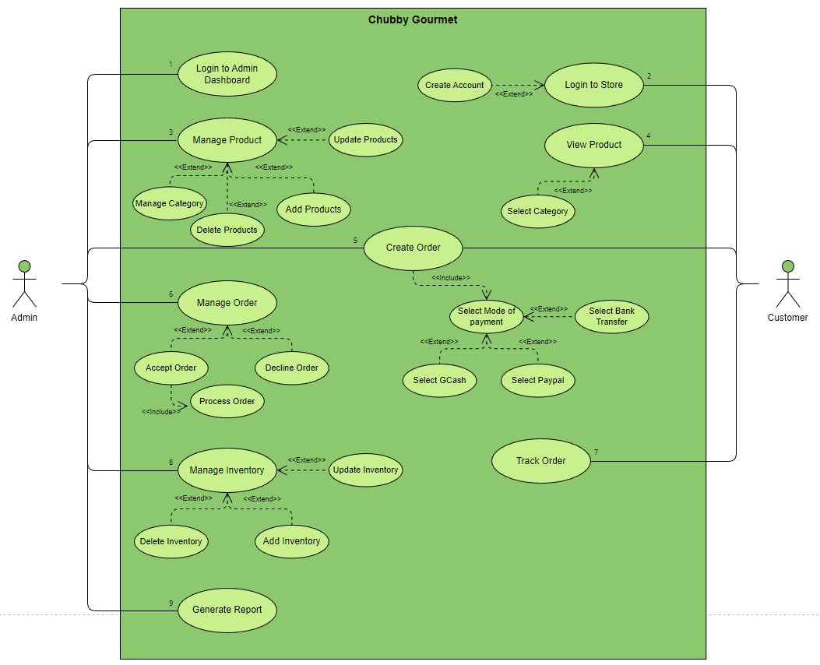

Fig. 8. Use Case Diagram

The proposed system’s use case diagram illustrates the various ways in which a user can interact with a system. This diagram summarizes information about the actors and their interactions.

Fig. 8 shows the two (2) actors that will be using the system namely: Customer, and Admin (Chubby Gourmet).

### Use Case Full Description

The following tables will discuss the use case description of each function that is needed in the development.

|  |  |
| --- | --- |
| **Number** | CG-1 |
| **Name** | Login to Admin Dashboard |
| **Summary / Description** | Chubby Gourmet logs in to have control over the web application. |
| **Preconditions** | Chubby Gourmet’s admin/s must input correct credentials |
| **Postconditions** | Chubby Gourmet has control over the web application. |
| **Actor/s** | Admin (Chubby Gourmet) |
| **Trigger** | Chubby Gourmet must input the correct username and password. |
| **Main Scenario (Basic Flow/s)** | |  |  | | --- | --- | | **Actor** | **System** | | 1. Admin opens Chubby Gourmet’s admin dashboard. | 1.1 System displays login form. | | 2. Admin inputs correct username and password. | 2.1 System verifies the username and password.  2.2 System authenticates the credentials | | 3. Admin has successfully logged in. | 3.1 System displays admin dashboard. | |
| **Exceptions** | 1. If Chubby Gourmet wants to change his/her password, he/she can click the “change password” button located on account settings. |

|  |  |
| --- | --- |
| **Number** | CG-2 |
| **Name** | Login to Store |
| **Summary / Description** | Customer logs in to Chubby Gourmet Web Application. |
| **Preconditions** | Customer must have a user account. |
| **Postconditions** | Customer can now explore the web application. |
| **Actor/s** | Customer |
| **Trigger** | Customer clicks the Login button. |
| **Main Scenario (Basic Flow/s)** | |  |  | | --- | --- | | **Actor** | **System** | | 1. Customer inputs their correct credentials. | 1.1 System displays login form | | 2. Customer clicks login. | 2.1 System verifies the username and password.  2.2 System authenticates the credentials. | | 3. Customer has successfully logged in. | 3.1 System displays Home Page. | |
| **Exceptions** | N/A |

|  |  |
| --- | --- |
| **Number** | CG-2.1 |
| **Name** | Create Account |
| **Summary / Description** | Customer creates a user account in Chubby Gourmet Web Application. |
| **Preconditions** | Customer must visit the Chubby Gourmet Web Application. |
| **Postconditions** | Customer successfully created an account. |
| **Actor/s** | Customer |
| **Trigger** | Customer clicks the Register button. |
| **Main Scenario (Basic Flow/s)** | |  |  | | --- | --- | | **Actor** | **System** | | 1. Customer clicks register button. | 1.1 System displays registration form | | 2. Customer inputs valid credentials. | 2.1 System verifies the username and password.  2.2 System authenticates the credentials. | | 3. Customer clicks confirm button. | 3.1 System prompted “Account Successfully Created” | |
| **Exceptions** | N/A |

|  |  |
| --- | --- |
| **Number** | CG-3 |
| **Name** | Manage Product |
| **Summary / Description** | Chubby Gourmet manages product information where he/she can perform create, read, update, and delete (CRUD) operations based on the availability of the products. |
| **Preconditions** | Chubby Gourmet must be logged into the admin dashboard. |
| **Postconditions** | Chubby Gourmet has control over *Products* tab |
| **Actor/s** | Admin |
| **Trigger** | Chubby Gourmet clicks the *Products* tab. |
| **Main Scenario (Basic Flow/s)** | |  |  | | --- | --- | | **Actor** | **System** | | 1. Admin clicks the *Products* tab. | 1.1 System displays Products Page. | |
| **Exceptions** | N/A |

|  |  |
| --- | --- |
| **Number** | CG-3.1 |
| **Name** | Add Products |
| **Summary / Description** | Chubby Gourmet can add a new product. |
| **Preconditions** | Chubby Gourmet must be at the Productspage. |
| **Postconditions** | Chubby Gourmet successfully added a new product. |
| **Actor/s** | Admin |
| **Trigger** | Chubby Gourmet clicks the *add product* button. |
| **Main Scenario (Basic Flow/s)** | |  |  | | --- | --- | | **Actor** | **System** | | 1. Admin clicks the *add product* button on the upper right corner of Products tab. | 1.1 System displays *add product* form. | | 2. Admin inputs the details of the new product. | 2.1 System allows admin to input details on the form. | | 3. Admin clicks the Confirm Button. | 3.1 System records the newly added product. | |
| **Exceptions** | 1. If Chubby Gourmet fails to confirm the new product, the application will be declined by the system, and it will not be displayed in the customer's UI. |

|  |  |
| --- | --- |
| **Number** | CG-3.2 |
| **Name** | Update Products |
| **Summary / Description** | Chubby Gourmet can update the availability of an existing product. |
| **Preconditions** | Chubby Gourmet must be at the Productspage. |
| **Postconditions** | Chubby Gourmet successfully updates a product. |
| **Actor/s** | Admin |
| **Trigger** | Chubby Gourmet clicks the edit button. |
| **Main Scenario (Basic Flow/s)** | |  |  | | --- | --- | | **Actor** | **System** | | 1. Admin clicks the edit button on a specific product. | 1.1 System allows admin to edit the details of the product. | | 2. Admin updates a specific detail. | 2.1 System records the newly updated product. | |
| **Exceptions** | 1. If Chubby Gourmet fails to update the availability of the products, it is possible that a customer can order an unavailable product. |

|  |  |
| --- | --- |
| **Number** | CG-3.3 |
| **Name** | Delete Products |
| **Summary / Description** | Chubby Gourmet can delete an existing product. |
| **Preconditions** | Chubby Gourmet must be at the Productspage. |
| **Postconditions** | Chubby Gourmet successfully removed an existing product. |
| **Actor/s** | Admin |
| **Trigger** | Chubby Gourmet clicks the delete button. |
| **Main Scenario (Basic Flow/s)** | |  |  | | --- | --- | | **Actor** | **System** | | 1. Admin clicks the delete button. | 1.1 System displays a removal notice. | | 2. Admin clicks the “yes” button. | 2.1 System will remove the product. | |
| **Exceptions** | 1. If Chubby Gourmet clicks “no” in removal notice, the deletion of the product will be declined by the system. |

|  |  |
| --- | --- |
| **Number** | CG-3.4 |
| **Name** | Manage Category |
| **Summary / Description** | Chubby Gourmet manages category information where he/she can perform create, read, update, and delete (CRUD) operations based on the category. |
| **Preconditions** | Chubby Gourmet must be logged into the admin dashboard. |
| **Postconditions** | Chubby Gourmet has control over *Category* tab |
| **Actor/s** | Admin |
| **Trigger** | Chubby Gourmet clicks the *Category* tab. |
| **Main Scenario (Basic Flow/s)** | |  |  | | --- | --- | | **Actor** | **System** | | 1. Admin clicks the *Category* tab. | 1.1 System displays Category Page. | |
| **Exceptions** | N/A |

|  |  |
| --- | --- |
| **Number** | CG-4 |
| **Name** | View Products |
| **Summary / Description** | Customers view the menu to see available products. |
| **Preconditions** | Customers must be logged in to the Chubby Gourmet web application. |
| **Postconditions** | Customers are aware of what products are available. |
| **Actor/s** | Customer |
| **Trigger** | Customer clicks the *Menu* tab. |
| **Main Scenario (Basic Flow/s)** | |  |  | | --- | --- | | **Actor** | **System** | | 1. Customer logs in to Chubby Gourmet web application. | 1.1 System displays the home page. | | 1. Customer clicks the *Menu* tab. | 2.1 System displays the available products. | |
| **Exceptions** | N/A |

|  |  |
| --- | --- |
| **Number** | CG-4.1 |
| **Name** | Select Category |
| **Summary / Description** | Customer selects a category of food they want to order. |
| **Preconditions** | Customer must be logged in. |
| **Postconditions** | Customer finds the product/s he/she wants. |
| **Actor/s** | Customer |
| **Trigger** | Customer clicks the *Menu* tab. |
| **Main Scenario (Basic Flow/s)** | |  |  | | --- | --- | | **Actor** | **System** | | 1. Customers must be at the Menu page. | 1.1 System displays category. | | 1. Customer clicks a specific food category. | 2.1 System displays all available food based on the selected category. | |
| **Exceptions** | N/A |

|  |  |
| --- | --- |
| **Number** | CG-5 |
| **Name** | Create Order |
| **Summary / Description** | Customers create their desired order/s. |
| **Preconditions** | Customers must be logged in. |
| **Postconditions** | Customers will now select for the mode of payment. |
| **Actor/s** | Customer |
| Admin |
| **Trigger** | Customer clicks the *add-to-cart* button then clicks the check-out button. |
| **Main Scenario (Basic Flow/s)** | |  |  | | --- | --- | | **Actor** | **System** | | 1. Customers *add-to-carts* a product. | 1.1 System displays selected products to customer's shopping cart. | | 1. Customer clicks the check-out button. | 2.1 System displays the order form. | | 1. Customer fills in order form. | 3.1 System displays order total. | |
| **Exceptions** | 1. If Customer accidentally clicked the *check-out* button, he/she can click the *home* button to go back to home page. |

|  |  |
| --- | --- |
| **Number** | CG-5.1 |
| **Name** | Select Mode of payment |
| **Summary / Description** | Customer selects mode of payment |
| **Preconditions** | Customer must already checked-out a product. |
| **Postconditions** | Customer must see the mode of payment option. |
| **Actor/s** | Customer |
| **Trigger** | Customer clicks the dropdownbutton. |
| **Main Scenario (Basic Flow/s)** | |  |  | | --- | --- | | **Actor** | **System** | | 1. Customer clicks the dropdown button. | 1.1 System displays mode of payment option. | |
| **Exceptions** | N/A |

|  |  |
| --- | --- |
| **Number** | CG-5.1.1 |
| **Name** | Select GCash |
| **Summary / Description** | Customer selects GCash as mode of payment. |
| **Preconditions** | Customer must see the mode of payment option. |
| **Postconditions** | Customer successfully placed an order. |
| **Actor/s** | Customer |
| **Trigger** | Customer clicks GCash as mode of payment. |
| **Main Scenario (Basic Flow/s)** | |  |  | | --- | --- | | **Actor** | **System** | | 1. Customer clicks GCash as mode of payment | 1.1 System displays Chubby Gourmet’s GCash details. | | 1. Customer must input their GCash credentials. (Name, GCash number) | 2.1 System will allow customer to input their credentials. | | 1. Customer will send their payment to Chubby Gourmet’s GCash account. | 3.1 System will allow customer to upload their proof of payment. | | 1. Customer will input the reference number of the transaction (GCash will provide the reference number of the transaction) | 4.1 System will upload the data in the database. | | 1. Customer will click confirm payment. | 5.1 System will display “Thank you” page. | |
| **Exceptions** | 1. If customer inputs invalid GCash credentials in the form, admin will hold their order and will email them requesting with their new and correct credentials.  2. If customer inputs invalid reference number, admin will verify the payment by viewing their GCash transaction history, and if it is confirmed that the payment is fake, the order will be declined. |

|  |  |
| --- | --- |
| **Number** | CG-5.1.2 |
| **Name** | Select Paypal |
| **Summary / Description** | Customer selects Paypal as mode of payment. |
| **Preconditions** | Customer must see the mode of payment option. |
| **Postconditions** | Customer successfully placed an order. |
| **Actor/s** | Customer |
| **Trigger** | Customer clicks paypal as mode of payment. |
| **Main Scenario (Basic Flow/s)** | |  |  | | --- | --- | | **Actor** | **System** | | 1. Customer clicks PayPal as mode of payment | 1.1 System displays the PayPal button | | 1. Customers clicks the PayPal button | 2.1 System will redirect to PayPal payment gateway | | 1. Customers will input their Paypal details in the PayPal gateway | 3.1 System will send a payment confirmation via email | |
| **Exceptions** | N/A |

|  |  |
| --- | --- |
| **Number** | CG-5.1.3 |
| **Name** | Select Bank Transfer |
| **Summary / Description** | Customer selects Bank Transfer as mode of payment. |
| **Preconditions** | Customer must see the mode of payment option. |
| **Postconditions** | Customer successfully placed an order. |
| **Actor/s** | Customer |
| **Trigger** | Customer clicks bank transfer as mode of payment. |
| **Main Scenario (Basic Flow/s)** | |  |  | | --- | --- | | **Actor** | **System** | | 1. Customer clicks Bank Transfer as mode of payment | 1.1 System displays the Bank Transfer form | | 1. Customers inputs their Bank Details. | 2.1 System will send a payment confirmation via email | |
| **Exceptions** | N/A |

|  |  |
| --- | --- |
| **Number** | CG-6 |
| **Name** | Manage Order |
| **Summary / Description** | Chubby Gourmet manages orders information where he/she can accept or delete orders. |
| **Preconditions** | Chubby Gourmet must be logged into the admin dashboard. |
| **Postconditions** | Chubby Gourmet is aware of pending orders. |
| **Actor/s** | Admin |
| **Trigger** | Chubby Gourmet clicks the *Orders* tab. |
| **Main Scenario (Basic Flow/s)** | |  |  | | --- | --- | | **Actor** | **System** | | 1. Admin clicks the *Orders* tab. | 1.1 System displays Orders Page database. | |
| **Exceptions** | N/A |

|  |  |
| --- | --- |
| **Number** | CG-6.1 |
| **Name** | Accept Order |
| **Summary / Description** | Chubby Gourmet accepts pending order. |
| **Preconditions** | Chubby Gourmet must be at Orders page. |
| **Postconditions** | Chubby Gourmet accepted the order. |
| **Actor/s** | Admin |
| **Trigger** | Chubby Gourmet clicks the *check* button. |
| **Main Scenario (Basic Flow/s)** | |  |  | | --- | --- | | **Actor** | **System** | | 1. Admin accepts pending orders. | 1. System displays the newly accepted order to the processing tab. | | 1. Admin modifies the order status. | 2. System updates the order status in customer’s *My Orders* page. | |
| **Exceptions** | N/A |

|  |  |
| --- | --- |
| **Number** | CG-6.2 |
| **Name** | Decline Order |
| **Summary / Description** | Chubby Gourmet declines the order. |
| **Preconditions** | Chubby Gourmet must be at Orders page. |
| **Postconditions** | Chubby Gourmet declined an order. |
| **Actor/s** | Admin |
| **Trigger** | Chubby Gourmet clicks the delete/trash button. |
| **Main Scenario (Basic Flow/s)** | |  |  | | --- | --- | | **Actor** | **System** | | 1. Admin clicks the delete button. | 1.1 System displays a removal notice. | | 1. Admin clicks “yes, decline the order”. | 2.1 System deletes the order  2.2 System updates the order status in customer’s *My Orders* page. | |
| **Exceptions** | 1. If Chubby Gourmet fails to delete unwanted pending order, the order will still be displayed to the orders page, and the customer will not receive any updates about the order. |

|  |  |
| --- | --- |
| **Number** | CG-7 |
| **Name** | Track Order |
| **Summary / Description** | Customer wants to track their order. |
| **Preconditions** | Customer must successfully place an order. |
| **Postconditions** | Customer knows the status of his/her order. |
| **Actor/s** | Customer |
| **Trigger** | Customer clicks *My Orders* page. |
| **Main Scenario (Basic Flow/s)** | |  |  | | --- | --- | | **Actor** | **System** | | 1. Customer successfully placed an order. | 1.1 System displays ‘Thank you’ landing page. | | 1. Customer clicks *My Orders* page. | 2.1 System displays updated order status. | |
| **Exceptions** | 1. If Chubby Gourmet fails to update an order, the customer will still see the previous order status. |

|  |  |
| --- | --- |
| **Number** | CG-8 |
| **Name** | Manage Inventory |
| **Summary / Description** | Chubby Gourmet manages inventory information where he/she can perform create, read, update, and delete (CRUD) operations based on the availability and quantity of the tools and ingredients. |
| **Preconditions** | Chubby Gourmet must be logged into the admin dashboard. |
| **Postconditions** | Chubby Gourmet has control over *Inventory* tab |
| **Actor/s** | Admin |
| **Trigger** | Chubby Gourmet clicks the *Inventory* tab. |
| **Main Scenario (Basic Flow/s)** | |  |  | | --- | --- | | **Actor** | **System** | | 1. Admin clicks the *Inventory* tab. | 1.1 System displays Inventory Page database. | |
| **Exceptions** | 1. If Chubby Gourmet fails to update the quantity of the ingredients, admin can have a problem in tracking the inventory. |

|  |  |
| --- | --- |
| **Number** | CG-8.1 |
| **Name** | Add Inventory |
| **Summary / Description** | Chubby Gourmet adds a new ingredient in inventory. |
| **Preconditions** | Chubby Gourmet must be at *Inventory* page. |
| **Postconditions** | Chubby Gourmet successfully added a new ingredient. |
| **Actor/s** | Admin |
| **Trigger** | Chubby Gourmet clicks the *add* button. |
| **Main Scenario (Basic Flow/s)** | |  |  | | --- | --- | | **Actor** | **System** | | 1. Admin clicks the *add* button on the Inventory page. | 1.1 System displays *add ingredients* form. | | 2. Admin inputs the details of the new ingredients. | 2.1 System allows admin to input details on the form. | | 3. Admin clicks the Add button. | 3.1 System records the newly added item. | |
| **Exceptions** | 1. If Chubby Gourmet fails to confirm the new item, the application will be declined by the system, and it will not be displayed in the Inventory page. |

|  |  |
| --- | --- |
| **Number** | CG-8.2 |
| **Name** | Update Inventory |
| **Summary / Description** | Chubby Gourmet can update the inventory. |
| **Preconditions** | Chubby Gourmet must be at *Inventory* page. |
| **Postconditions** | Chubby Gourmet successfully updates the inventory. |
| **Actor/s** | Admin |
| **Trigger** | Chubby Gourmet clicks the edit icon. |
| **Main Scenario (Basic Flow/s)** | |  |  | | --- | --- | | **Actor** | **System** | | 1. Admin clicks the edit icon on a specific ingredient. | 1.1 System allows admin to edit the remaining quantity of ingredients. | | 2. Admin updates the quantity. | 2.1 System records the newly updated remaining quantity. | |
| **Exceptions** | 1. If Chubby Gourmet fails to update the remaining quantity of the ingredients, the system will still display the previous quantity of the inventory. |

|  |  |
| --- | --- |
| **Number** | CG-8.3 |
| **Name** | Delete Inventory |
| **Summary / Description** | Chubby Gourmet can delete an existing ingredient. |
| **Preconditions** | Chubby Gourmet must be at *Inventory* page. |
| **Postconditions** | Chubby Gourmet successfully removed an existing ingredient. |
| **Actor/s** | Admin |
| **Trigger** | Chubby Gourmet clicks the delete button. |
| **Main Scenario (Basic Flow/s)** | |  |  | | --- | --- | | **Actor** | **System** | | 1. Admin clicks the delete button. | 1.1 System displays a removal notice. | | 2. Admin clicks “yes” button. | 2.1 System will remove the ingredient. | |
| **Exceptions** | 2. If Chubby Gourmet clicks “no” in removal notice, the deletion of product will be declined by the system. |

|  |  |
| --- | --- |
| **Number** | CG-9 |
| **Name** | Generate Reports |
| **Summary / Description** | Chubby Gourmet can see, analyze, and print the total sales, total orders of each product, best-selling products, and periodical sales. |
| **Preconditions** | Chubby Gourmet must be logged into the admin dashboard. |
| **Postconditions** | Chubby Gourmet analyzed the reports. |
| **Actor/s** | Admin |
| **Trigger** | Chubby Gourmet clicks the *Reports* tab |
| **Main Scenario (Basic Flow/s)** | |  |  | | --- | --- | | **Actor** | **System** | | 1. Admin clicks the *Reports* tab. | 1.1 System displays Reports Page database. | | 1. Admin clicks the *sales* tab. | 2.1 System displays total sales. | | 1. Admin clicks *print as PDF* button. | 3.1 System saves a PDF copy of the report. | |
| **Exceptions** | N/A |

## Gap Analysis

Table VI discusses the difference between the processes of the current system and the proposed changes with their corresponding impact for the business processes.

TABLE VI   
GAP ANALYSIS

|  |  |  |  |
| --- | --- | --- | --- |
| Product Backlog ID | Current System | Proposed Changes | Impact |
| CG-1 | Admin uses their personal Facebook page to manage their business | Dedicated account for admin to manage their business and emails | Admin can access the dashboard without using any personal information |
| CG-2 | Admin posts new and available products through their Facebook page | Admin can create, read, update, and delete their products. | Systematic way of managing their products eliminating the need to post available products every day. |
| CG-3 | Admin checks their Messenger for the orders and manually lists them down on a white board. | Admin can see new orders in an organized way | A faster and more organized way of managing orders because the admin can see new orders in a glance |
| CG-4 | Admin manually computes their sales on a notebook | Admin can get periodic reports automatically | Automatic generation of sales eliminating the need to compute manually |
| CG-5 | Admin manually lists down current inventory on a notebook | Admin can modify their inventory in an organized way | Faster and more organized way of managing inventory |
| CG-6 | Customer uses their personal Facebook page to order | Customer can choose whether to create a new account or use their current Facebook or Google Account | Customer can create an account using different social media platforms |
| CG-7 | Customer views the products via Photo tab in the Facebook page | A dedicated “Menu” tab to display available products for the day | Easier browsing for the customers because they can see the available products quickly |
| CG-8 | Customer sends a message through Messenger regarding order form and payment creation | A systematic way of adding an item to cart up to payment creation | Customer does not need to wait for the admin to reply when ordering |
| CG-9 | Customer sends a query regarding the status of their order | A dedicated “My Orders” tab to store current and past transactions | Customer can easily access their transaction history on a single place |

## System Analysis and Design

This subsection presents different diagrams which will be used in creating the system. The following diagrams are as follows: Context Diagram, Data Flow Diagram, Entity-Relationship Diagram, Activity Diagram, Object Diagram, Class Diagram, Sequence Diagram, State Machine Diagram, Deployment Diagram, Package Diagram, Component Diagram, and Data Dictionary.

### A picture containing diagram Description automatically generatedContext Diagram

Fig. 9. Current System - Context Flow Diagram

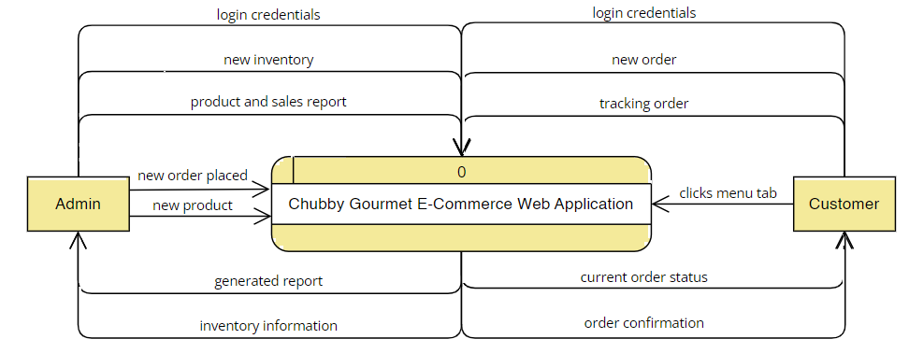

Fig. 9 and 10 shows the difference between the current system of Chubby Gourmet using Facebook Page and the proposed system named Chubby Gourmet E-Commerce Web Application. The proposed system has a greater number of flow lines because the proposed system will help the admin to solve their business problems. One example of this is the manage inventory. In here, the admin can track their current inventory easily since it is beside the managing of orders which gives easier navigation for the admin. In addition, even though the customer has greater number of lines on the proposed system, it is not a disadvantage since the process of ordering will be organized for them, for example, the orders can be tracked using the “My Orders” tab compared to tracking and storing their orders using Facebook Messenger.

Fig. 10. Proposed System - Context Flow Diagram

### Data Flow Diagrams

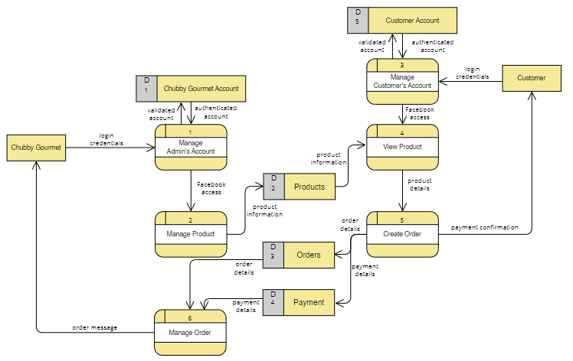

Fig. . Current System - Level 0

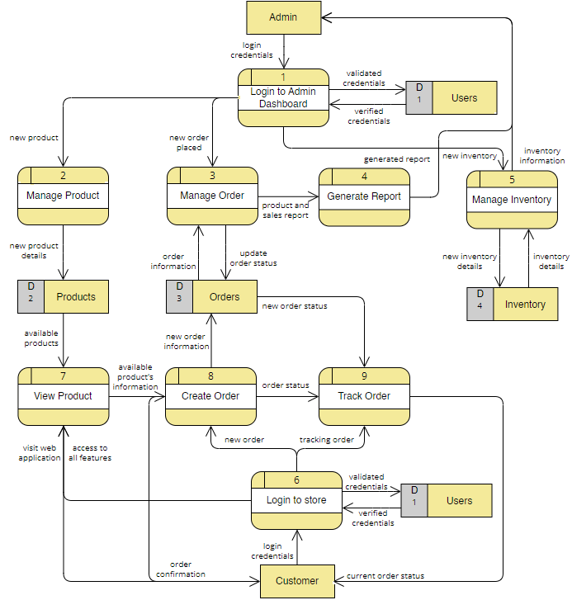

Fig. . Proposed System - Level 0

Fig. 11 and 12 shows the difference between the Level 0 of the current system and the proposed system. In here, the current system has 6 processes and 5 data stores. However, the proposed system has 9 processes due to the additional features that can help the admin to improve their business processes. Also, the proposed system has 11 data stores in total.

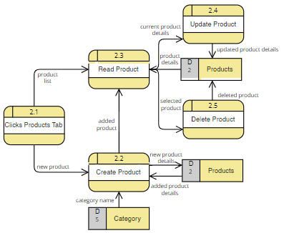

Fig. . Manage Product - Level 1

Fig. 13 shows the detailed data flow of Manage Product process. In here, two (2) data stores named Products and Category will be used. In addition, processes such as Clicks Products Tab, Create Product, Read Product, Update Product, and Delete Product makes up the whole Manage Product process.

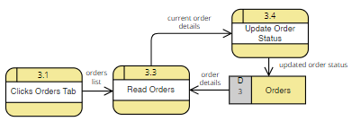

Fig. . Manage Order - Level 1

Fig. 14 shows the detailed data flow of Manage Order process. In here, the data store named Orders will be used to display the orders made by the customers. Moreover, a process named Update Order Status updated the content of the data store, specifically, the order status.

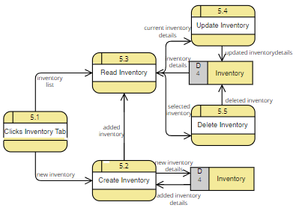

Fig. . Manage Inventory - Level 1

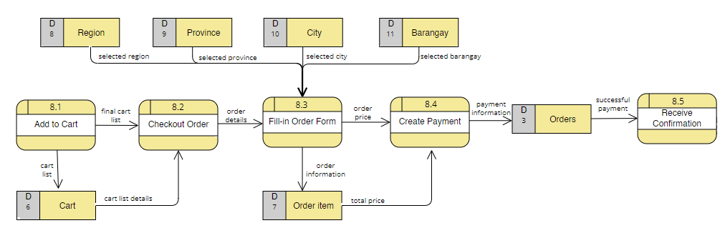Fig. 15 shows the detailed data flow of the Manage Inventory process. In here, the data store named Inventory will be used. Moreover, processes such as Clicks Inventory Tab, Create Inventory, Read Inventory, Update Inventory, and Delete Inventory makes up the whole Manage Inventory process.

Fig. . Create Order - Level 1

Fig. 16 shows the detailed data flow of the Create Order process. In here, data flows such as Orders, Cart, Order Item, Region, Province, City, and Barangay will be used. First, the customer can add an item to cart. Second, once the customer checks out their order, they will be required to fill-in an order form. In here, the customer must choose their Region, Province, City, and Barangay since the delivery range of the business is limited. Moreover, once they fill-in the order form, it will go to the order item data store, and they can proceed to Create Payment. Once the payment is made, it will go to the Orders data store and the customer will receive a confirmation.

### Entity-Relationship Diagrams

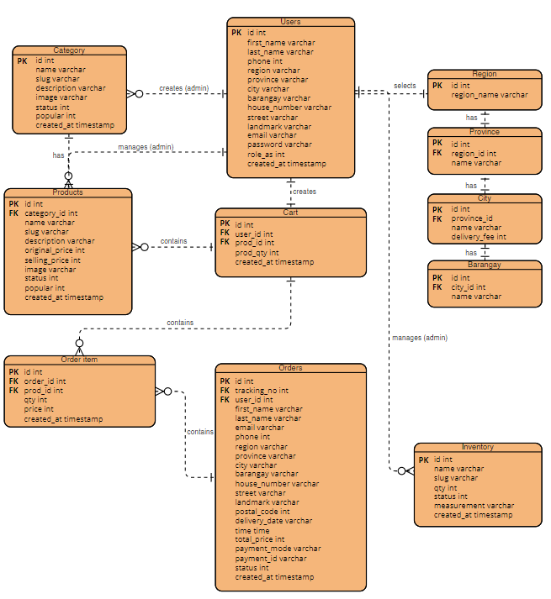

Fig. . Entity-Relationship Diagram

Fig. 17 shows that there will be 11 entities for the database design of the system. These entities are as follows: Users, Cart, Category, Products, Order Item, Orders, Region, Province, City, Barangay, and Inventory. Also, it shows the corresponding attributes for each entity and their relationship with each other.

### Activity Diagrams

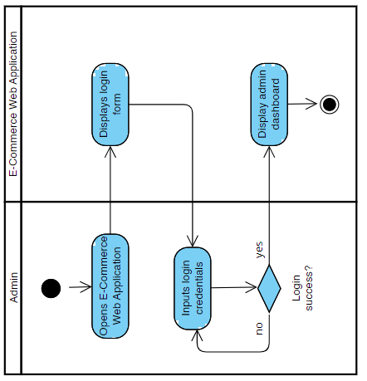

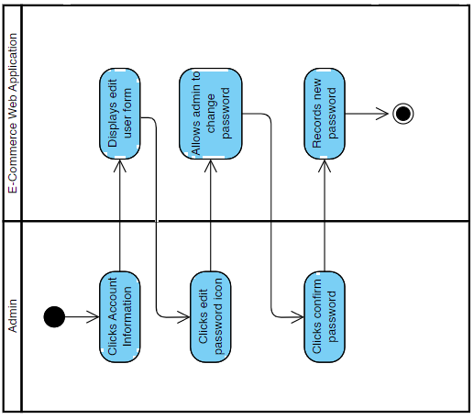

Fig. . Manage Admin's Account (Login and Change Password)

Fig. 18 shows how the process of how the admin interacts with the web application. Specifically, in the *Login to Admin Dashboard* use case. It starts with Fig. 18 where the admin will open the link of the E-Commerce Web Application, then it will display the login form wherein the admin can input their login credentials. If the login is unsuccessful, the admin will be required to login again. However, if the login is successful, the admin will now have access to the admin dashboard and the admin’s account management.

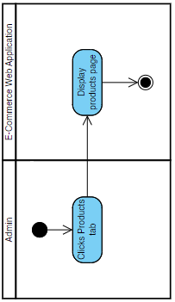Moreover, when the admin can now access the dashboard, the admin can click the account settings to update or change their login credentials. The web application will display a form and the admin can update it by inputting the new login credentials and clicking the confirm changes button.

Fig. . Manage Product

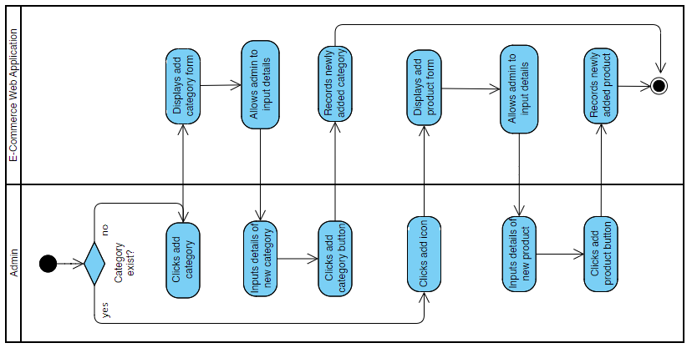

Fig. . Create product

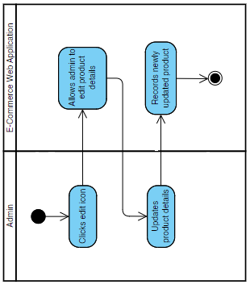

Fig. . Update Product

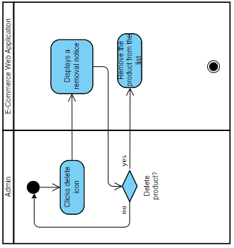

Fig. . Delete Product

Fig. 19 through 22 shows how the admin can manage their products in the admin dashboard. Managing the products starts when the admin clicks on the *Products* tab. When the system displays the products page, the admin can choose whether to update, create, or delete a product. If the admin wants to create a product and the category of it is not existing, the admin must create the category first. On the other hand, if the category of the products already exists, the admin can immediately proceed on creating a product. Moreover, If the admin is going to update a product, the admin needs to click the edit icon and the system will allow the admin to update the form that contains the product details. The admin will then input the details of the new product and a confirmation button is required to be clicked so that the data will be saved in the *Products* database.

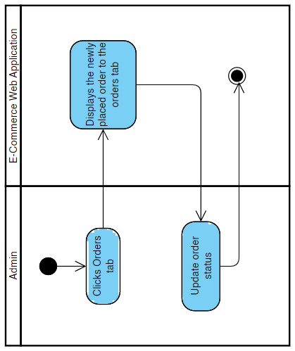

Fig. . Manage Order

Fig. 23 shows how the admin can update the order status of a customer. It starts with the admin going to the orders tab. Next, the system will display the placed orders. Lastly, the admin can update the order status of a specific order. It can be Processing, Shipping, Completed, or Cancelled.

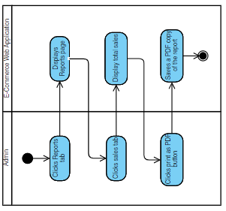

Fig. . Generate Report

Fig. 24 shows how the admin can access the reports of sales and products of their business. It starts when the admin clicks on the *Reports* tab, and it will show the list of sales and the summary of sales. If the admin wishes to print the report, the admin can click the print as PDF button and the system will save it as a PDF file in the local storage.

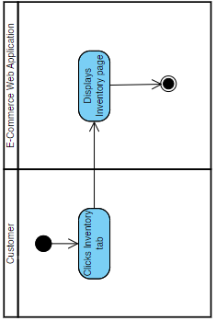

Fig. . Manage Inventory

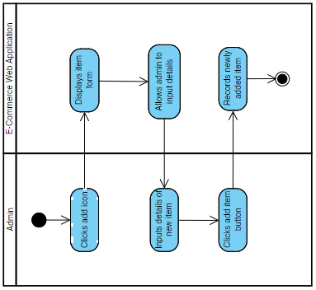

Fig. . Create Inventory

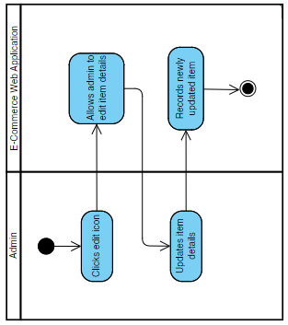

Fig. . Update Inventory

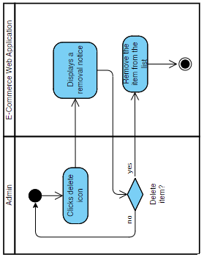

Fig. . Delete Inventory

Fig. 25 through 28 shows how the admin can create, update, and delete their inventory. It starts with the admin accessing the *Inventory* page. If the admin wishes to create an item, the admin needs to click the add icon, this will prompt the web application to display the form of the item where the user needs to fill in. Once done, it will be saved in the *Inventory* database. On the other hand, if the admin wishes to update an item in the inventory, the admin needs to click the edit icon. The web application will allow the admin to edit the details of the item. When the admin is done updating the information, the web application will save the updated data in the database. However, if the admin wants to delete an item, the admin needs to click the delete icon and there will be a removal notice to avoid the unintentional deletion of an item. If the admin wishes to proceed with the deletion of the item, the item will be removed in the database.

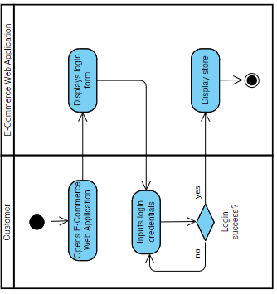

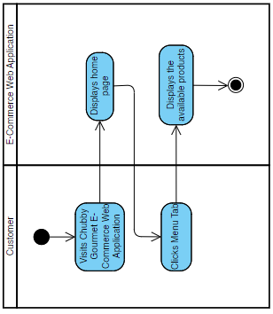

Fig. . Login to store

Fig. 29 shows how the process of how the customer interacts with the web application. Specifically, in the *Login to store* use case. It starts with Fig. X where the admin will open the link of the   
E-Commerce Web Application, then it will display the login form wherein the customer can input their login credentials. If the login is unsuccessful, the customer will be required to login again. However, if the login is successful, the customer will now have access to features such as ordering, editing their profile, and tracking their orders.

Fig. X through X shows how the customer views the menu. It starts when the customer searches the link of the web application. Then, once the home page is displayed, the customer can proceed to the *Menu* tab to view the available products.

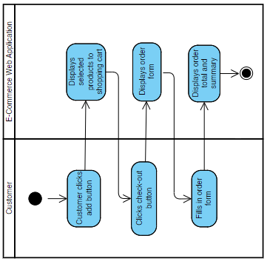

Fig. . Create Order

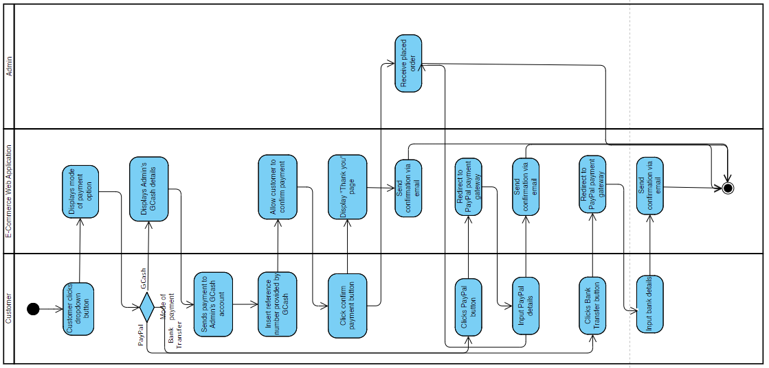

Fig. . Select Mode of Payment

Fig. 30 and 31 shows the process of how the customer can place an order successfully. It starts when the customer clicks the add button on their desired product, then the system will display the added product to the customer’s shopping cart. Once the customer is done adding products to the cart, he/she can now click the check-out button to proceed to the order form. The customer is required to fill in the order form since it will be used for the shipping process by the admin. When this process is done, the customer will click the proceed to payment button where he/she will have two (3) payment options, either via GCash, PayPal, or Bank Transfer. If the customer chooses GCash, the web application will display the GCash details of the admin. The customer can now pay via the GCash mobile application. After paying, the customer is required to type-in the reference number provided by GCash. Once the “confirm payment button” is clicked, the web application will display a *Thank You* page and the admin can see the newly placed order in the admin dashboard at the same time. However, if the customer chooses to pay via PayPal, the web application will redirect to the PayPal payment gateway. In here, the customer must input their PayPal account details. On the other hand, if the customer chooses Bank Transfer, it will also redirect to the PayPal gateway, but the required account details will be their debit/credit bank account details. Once it is done, the web application will send a confirmation via email to the customer and the admin can see the newly placed order in 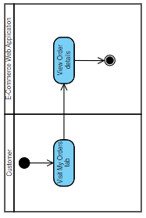the admin dashboard at the same time.

Fig. . Track Order

Fig. 32 shows how the customer can track their order. In here, the customer must be at the Orders tab wherein their current and past transactions are stored. Next, the customer can view the order details of a specific order. In here, it will show the status of their order whether it is still processing, shipping, completed, or cancelled.

### Object Diagrams

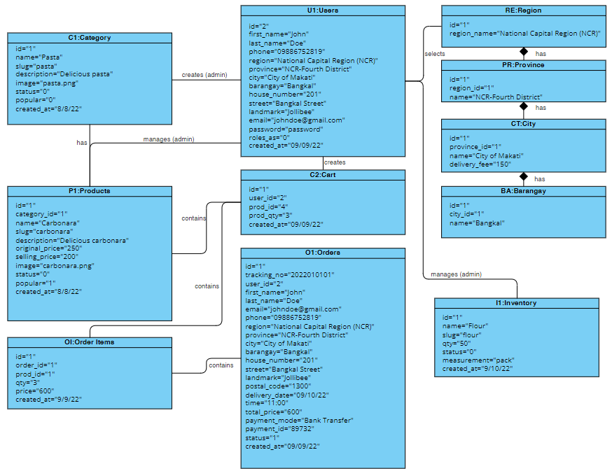

Fig. . Object Diagram

Fig. 33 contains the object diagram of the system. It presents how objects interacts with each other to explain further how the system works in a real-world situation. Moreover, given the sample values, this diagram also shows what data will be transferred to the database.

### Class Diagrams

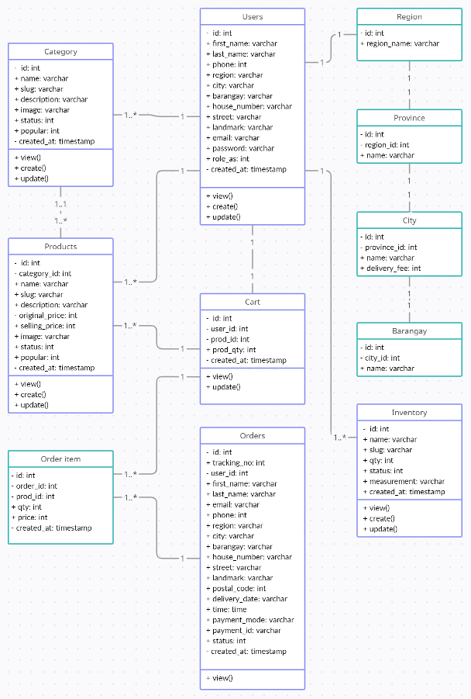

Fig. . Class Diagram

### Sequence Diagrams

A sequence diagram shows the logic between the entities in the system in the time sequence that the interactions occur. It also describes how and in what order a group of objects works together.

The sequence diagram of Chubby Gourmet discusses how Admin and Customer perform their task in the system in sequential order. All the methods performed by the actors are done within the system.

Fig. . Manage Admin's Account

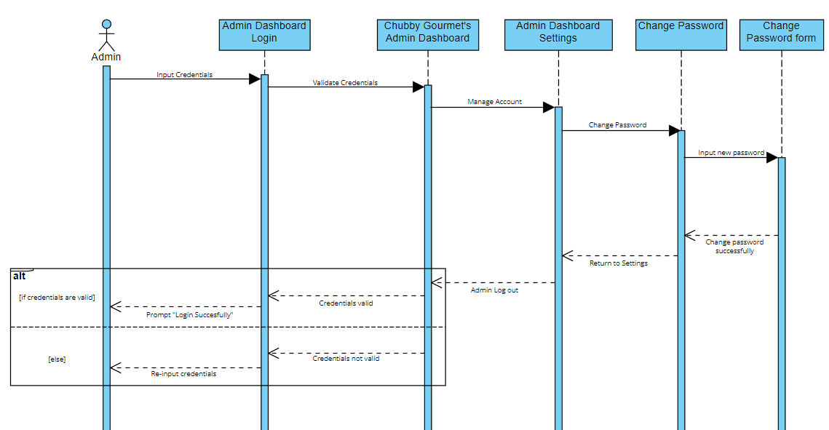

Fig. 35 shows the sequence diagram of the proposed account management. In this diagram, it shows that the admin needs to input his/her credentials to login, then after that the system will display the admin dashboard wherein admin can manage the admin’s account.

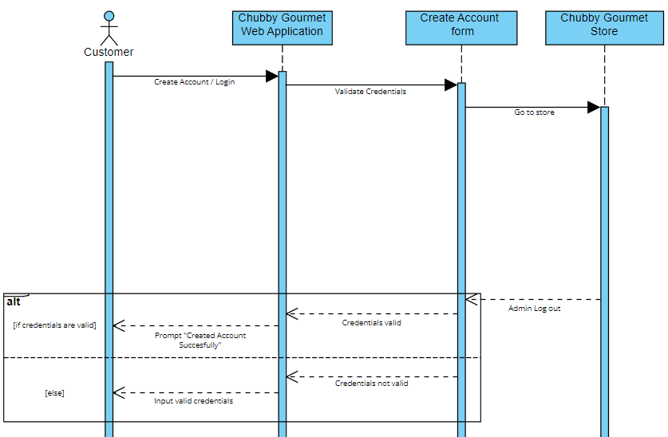

Fig. . Login to store

Fig. 36 shows the sequence diagram of the proposed customer login/creation of account. In this diagram, it shows that the customer needs to input his/her credentials to login, then after that the system will display the home page wherein customer can explore the store.

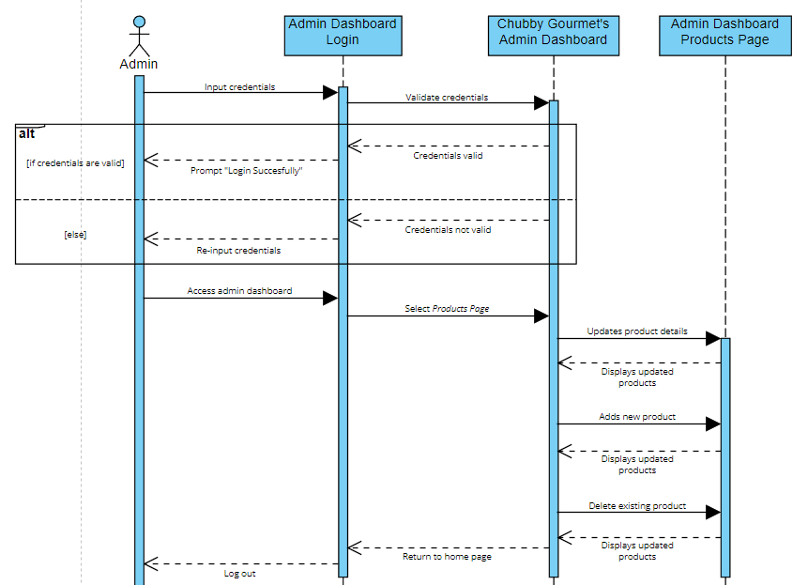

Fig. . Manage Product

Fig. 37 shows the sequence diagram of the proposed management of products. In this diagram it shows how the admin can create, update, and delete the products. Admin must be logged in to manage the products. If the admin wishes to create a new product, the admin needs to click the add product button, then the system will display the form of the product where the user needs to fill in. If the admin wishes to update an existing product, the admin needs to click the edit button. The system will allow the admin to edit the details of the product. Lastly, if the admin wants to delete an existing product, the admin needs to click the delete button and there will be a removal notice to avoid the unintentional deletion of an item. If the admin wishes to proceed with the deletion of the product, the item will be removed in the database.

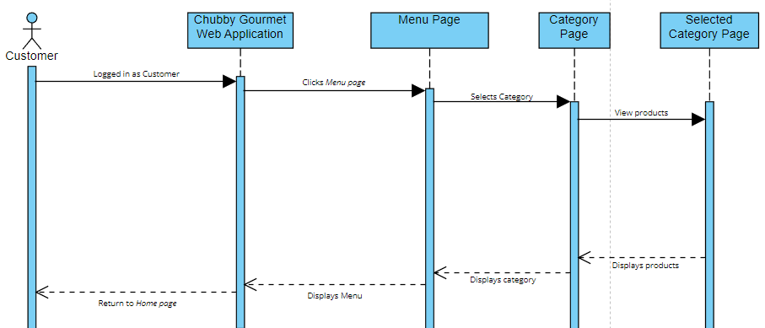

Fig. . View Product

Fig. 38 shows the sequence diagram of customer viewing products. In this diagram, it shows that customer needs to be logged in in Chubby Gourmet’s web application to view the products.

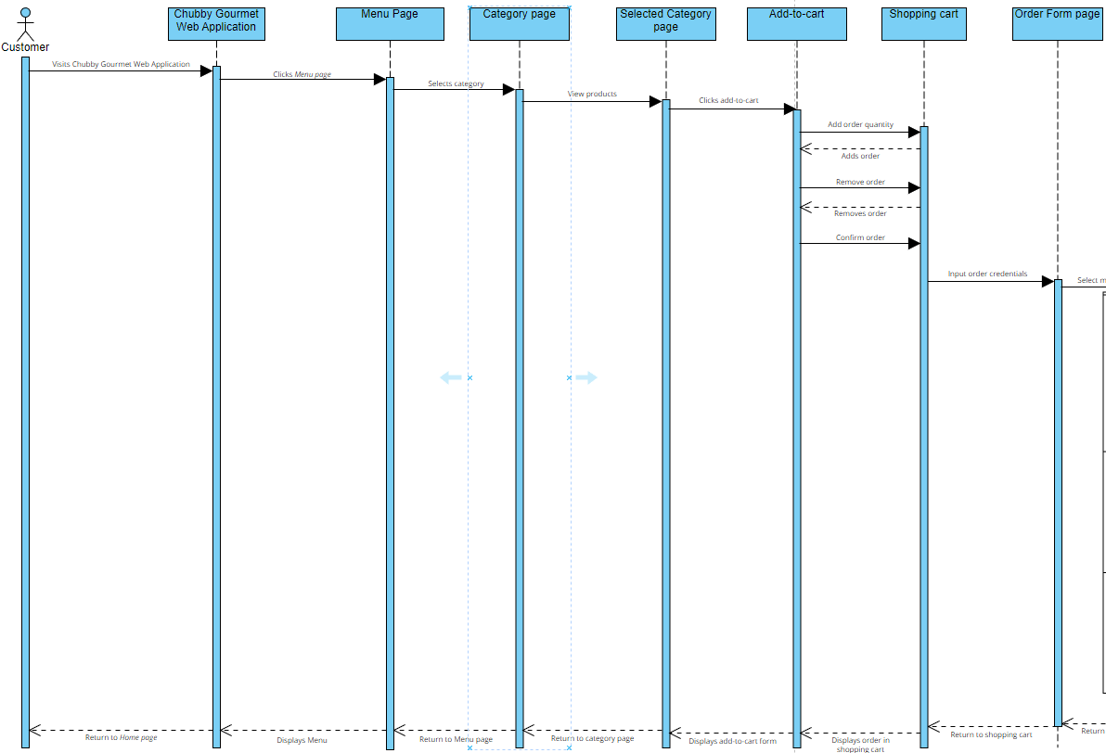

Fig. . Create Order (Part 1)

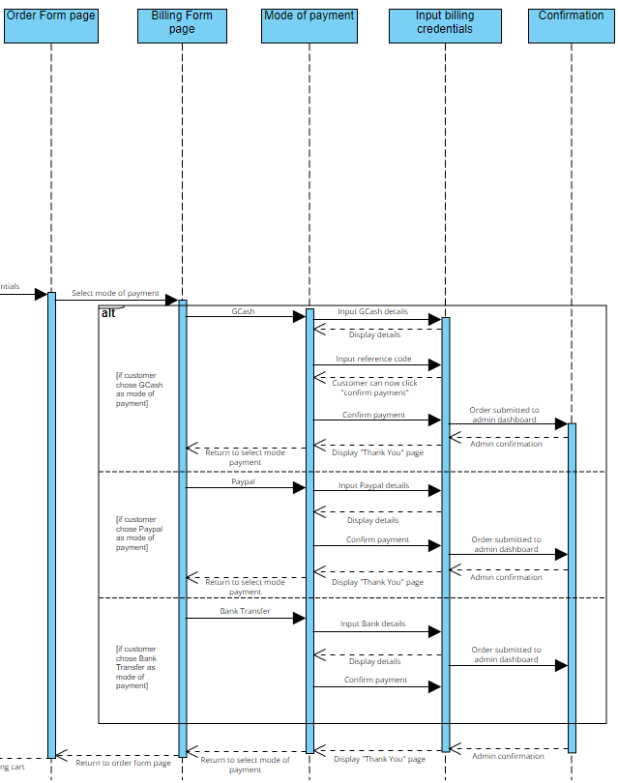

Fig. . Create Order (Part 2)

Fig. 39 and 40 shows the sequence diagram of the proposed Create Order. In this diagram, it shows the sequential order of how customer can place an order. It starts with the customer being able to visit Chubby Gourmet’s web application, then after that he/she needs to view products by clicking the Menu tab at the navigation bar. When the customer finally has an order in mind, he/she needs to click the add button besides the product for it to be added in the cart. Customer can also delete the products in the cart by just clicking the trash/delete icon. After confirming the order, the system will display the order form, and by that time, customer needs to input his/her credentials to proceed to the billing phase. In billing, the customer will have an option to choose for the mode of payment. Customer can use either through GCash, Paypal or Bank Transfer, after that they must input their billing credentials to confirm their order.

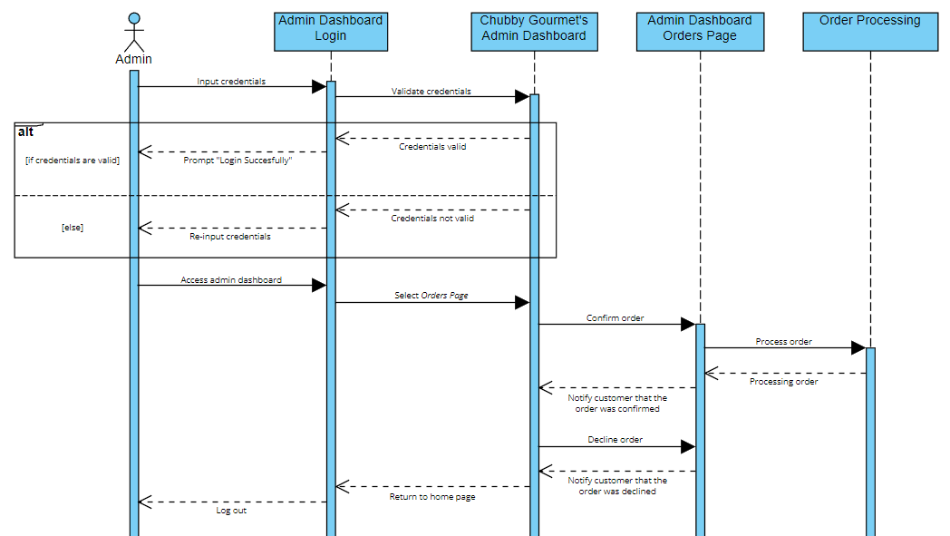

Fig. . Manage Order

Fig. 41 shows the sequence diagram of admin managing orders. In this diagram, it shows that admin need to be logged in to perform this task. By managing orders, admin must be in the Orders page in admin dashboard, wherein admin can see the pending orders. Admin can accept or delete the pending orders. When admin accepts an order, the system will update the order status to the customer *My Orders* page. In the other hand, if admin wants to delete a specific order, it will be removed in the pending orders lists.

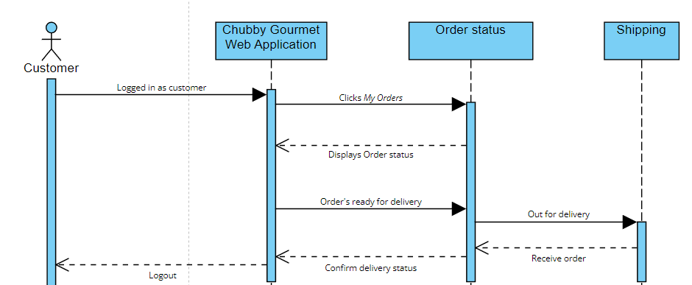

Fig. . Track Order

Fig. 42 shows the sequence diagram of customer tracks the order. In this diagram, it shows that for customer to track his/her order, customer needs to be logged in. The system will update the order status when admin accepts the order. If the order is completed, the system will update the status to “completed” and it will stay to the order history of the customer.

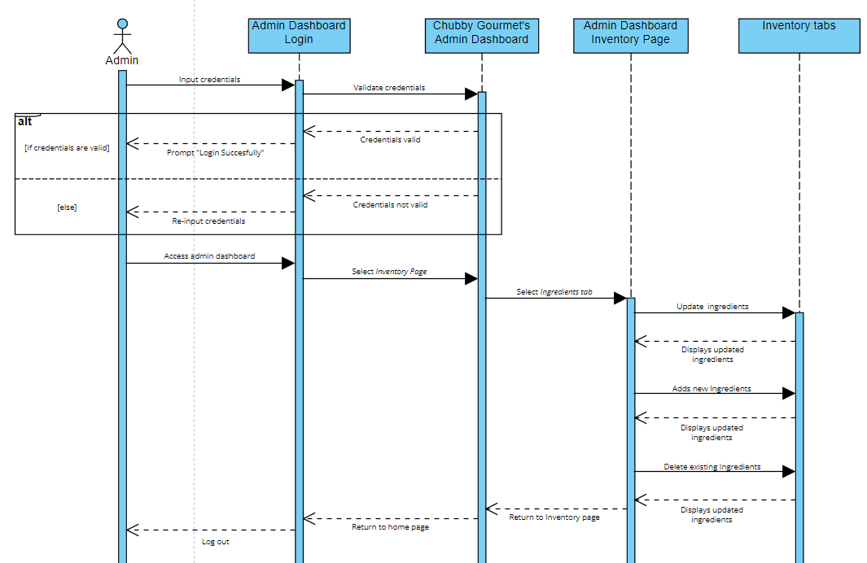

Fig. . Manage Inventory

Fig. 43 shows the sequence diagram of admin managing the inventory. In this diagram, it shows how the admin can create, update, and delete their inventory. Admin must be logged in to manage the inventory. If the admin wishes to create a new item, the admin needs to click the add ingredient button, then the system will display the form of the item where the user needs to fill in. If the admin wishes to update an existing item, the admin needs to click the edit button. The system will allow the admin to edit the details of the item. Lastly, if the admin wants to delete an existing item, the admin needs to click the delete button and there will be a removal notice to avoid the unintentional deletion of an item. If the admin wishes to proceed with the deletion of the item, the item will be removed in the database.

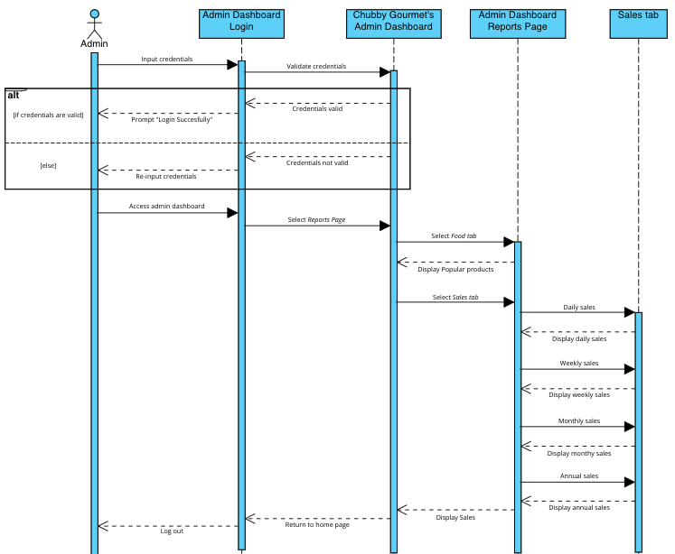

Fig. . Generate Report

Fig. 44 shows the sequence diagram of generation of reports. In this diagram, it shows how admin performs a task to view/see the reports. First, admin must be logged in in the admin dashboard, then he/she will proceed to the reports page by clicking the Reports button. The system will display the periodic sales and the top selling products, wherein admin can read or print the output.

### State Machine Diagram

A State Machine Diagram illustrates how objects behave in the context of a series of system events. It is also used to illustrate the behavior of an interface or class since it emphasizes an object's event-driven behavior.

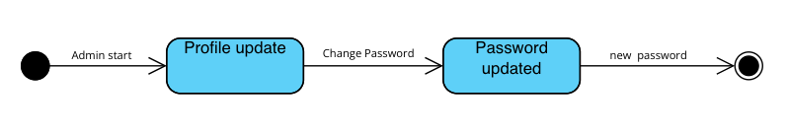

Fig. . Change Password

Fig. 45 illustrates the state transition diagram for changing of admin’s password. It starts with the profile update state wherein the admin wants to change the admin’s password. If admin successfully changes the password, then the next state will be the Password updated state wherein admin has a new password.

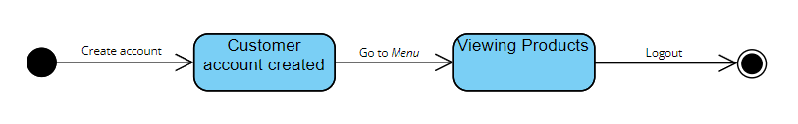

Fig. . Customer Account

Fig. 46 shows the state transition diagram for creating customer account. It starts with the customer clicking the register button, then the system will display registration form wherein customer need to input his/her valid credentials. If the system successfully validates the registration, customer can now explore the store as a Chubby Gourmet customer.

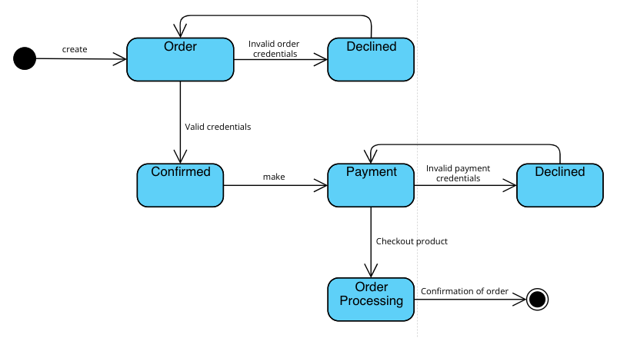

Fig. . Create Order

Fig. 47 illustrates the state transition diagram for customer creating an order. It starts with the customer placing an order, and if he/she inputs invalid credentials the state will be declined, and it will go back to the order state. However, if the credentials that customer inputs are valid then it will lead to payment. If customer inputs invalid billing credentials, then the request will be declined, and it will go back to the payment state. However, if it is valid then the order will be confirmed, and admin will start the processing of order.

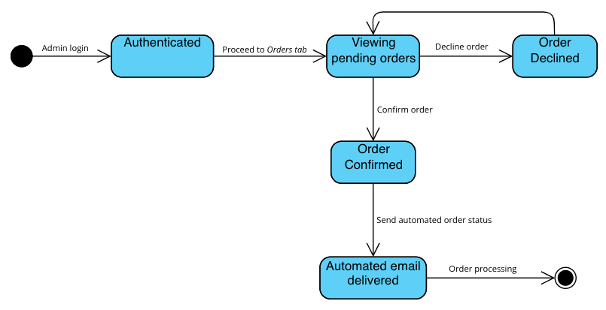

Fig. . Manage Order

Fig. 48 illustrates the state transition diagram for admin managing the orders. It starts with the admin inputting his/her credentials in the admin dashboard, and if it’s authenticated then the admin will proceed to the Orders tab. Admin views pending orders wherein, he can accept or decline the orders. If he wants to decline the order, then the order will be declined, and the state will go back to the viewing pending orders. However, if admin wants to accept the order, then the order will be confirmed, and the system will update the order status which will also be seen by the customer in their *My Orders* page.

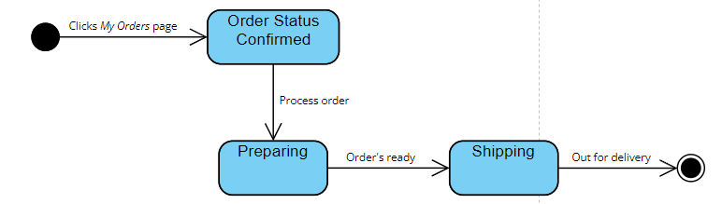

Fig. . Order Status

Fig. 49 illustrates the state transition diagram for tracking of order. It starts with the customer clicking the *My Orders* page. When the order confirmed by the admin, the system will automatically update the order status as “processing”. When the order was completed and delivered, the system will update the order status as “completed” and it will be displayed in the order history of the customer.

### Diagram Description automatically generatedDeployment Diagram

Fig. . Deployment Diagram

Fig. 50 shows the Deployment Diagram of the proposed web application. Moreover, it also shows the hardware and software that will make up the whole system. The customer and admin have their own devices, such as PC, to access the web application. The server contains both the Ordering Web Application and the Admin Dashboard. The Admin Dashboard is where the managing of products, orders, and inventories are happening. It is only accessible for the admin since it requires a login credentials. On the other hand, the Ordering Web Application is where the customer places their order and make payment. Moreover, when the customer chooses PayPal as their mode of payment, the web application will redirect it to the PayPal gateway. Lastly, the system will be using MySQL 8.0 as the database.

### Package Diagram

A Use Case Package Diagram are structural diagrams based in Use Case diagram that used to show the organization and arrangement of various model elements in the form of packages.

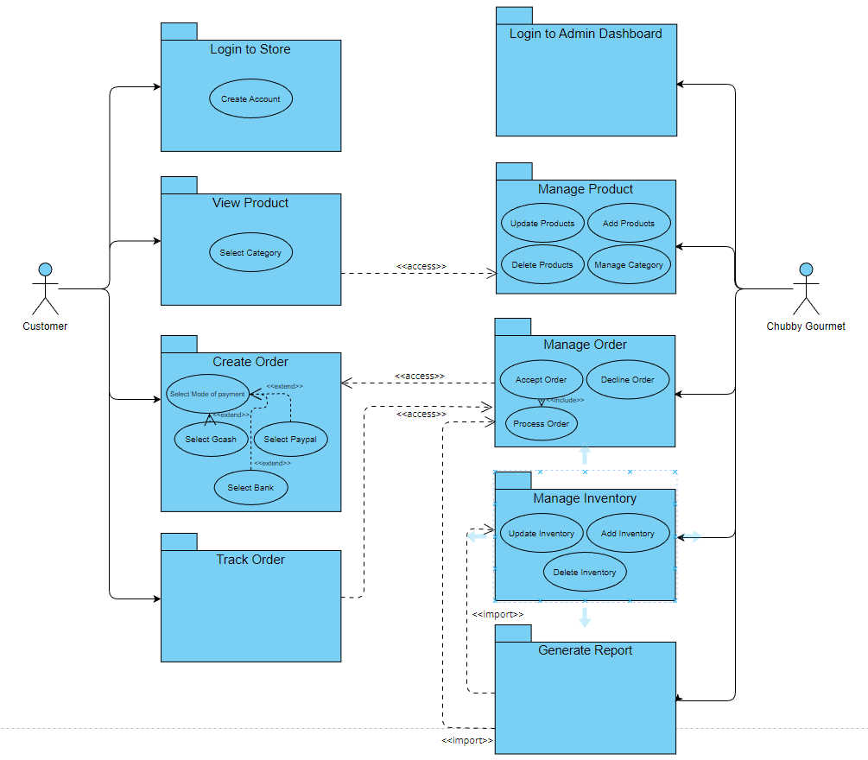

Fig. . Package Diagram

Fig. 51 shows the organization and connection of packages in an access connection and import connection. We can also see the contents of the packages which is the use cases that connects in either extend or include.

### Component Diagram

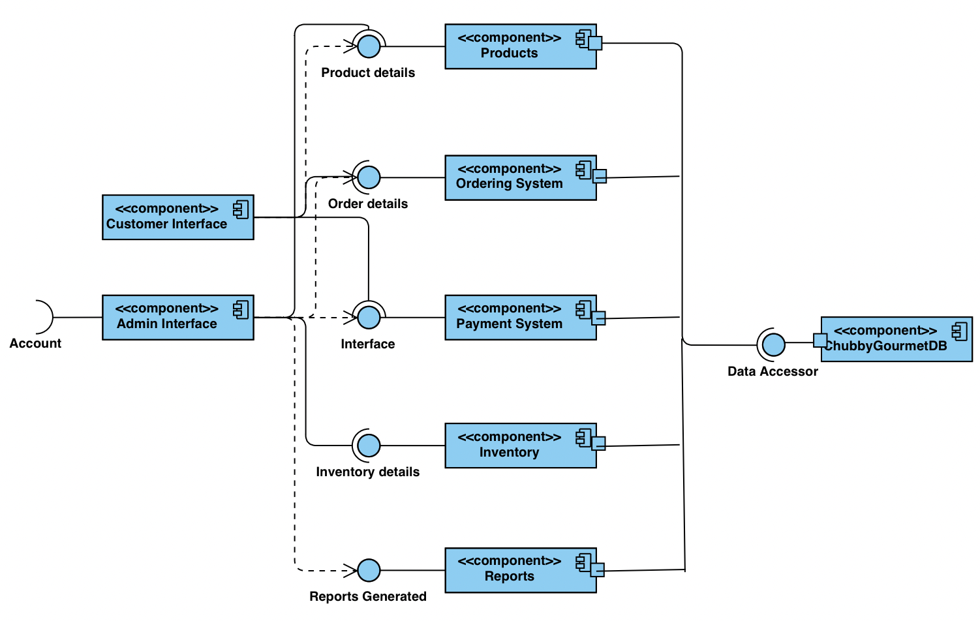

Fig. . Component Diagram

Fig. 52 shows the component diagram of the proposed system. In here, the Customer Interface component can access some components such as Ordering System, and Payment System. Moreover, it imports the Products component to see the product details. On the other hand, the Admin Interface requires an Account input so that it can access some components such as Products, and Inventory. Moreover, it imports the components named Ordering System, Payment System, and Reports because the admin needs the data in these components. Lastly, these components are all accessing the ChubbyGourmetDB, the database in MySQL 8.0.

### Data Dictionary

TABLE VII   
PRODUCTS

|  |  |  |  |
| --- | --- | --- | --- |
| PK/FK | Field Name | Data Type | Description |
| PK | productID | Int | ID number of the product |
| FK | categoryID | Int | Category ID where products will be assigned under |
|  | Prod_image | Varchar | Image of the product |
|  | Prod_name | Varchar | Product’s name |
|  | Prod_description | Varchar | Product’s description |
|  | Prod_available | Boolean | Product’s availability |
|  | Prod_category | Varchar | Product’s category name |
|  | Prod_variation | Varchar | Specific variant of the customer’s order (Ex. Size of tray) |

TABLE VIII   
CATEGORY

|  |  |  |  |
| --- | --- | --- | --- |
| PK/FK | Field Name | Data Type | Description |
| PK | categoryID | Int | Category ID where products will be assigned under |
|  | category_name | varchar | Category’s name |

TABLE IX   
ORDERS

|  |  |  |  |
| --- | --- | --- | --- |
| PK/FK | Field Name | Data Type | Description |
| PK | orderID | Int | ID number of the customer’s order |
| FK | CityID | Int | Order location identifier for the transaction of customer’s order |
|  | Order_name | Varchar | Name of the product |
|  | Order_qty | Int | Quantity of the order |
|  | Order_price | Int | Price of the customer’s order |
|  | Customer_fname | Varchar | Customer’s first name |
|  | Customer_lname | Varchar | Customer’s last name |
|  | Customer_email | Varchar | Customer’s email |
|  | Customer_pnumber | Int | Customers’ phone number |
|  | Customer_address | Varchar | Customer’s address |
|  | Customer_postalcode | Int | Customer’s postal code |
|  | Customer_deliverydate | Datetime | Customer’s delivery date |
|  | Customer_message | Varchar | Customer’s message along with order |

TABLE X   
CITY

|  |  |  |  |
| --- | --- | --- | --- |
| PK/FK | Field Name | Data Type | Description |
| PK | cityID | Int | Order location identifier for the transaction of customer’s order |
|  | City_name | varchar | Name of the city the customer’s location is under |
|  | City_fee | int | Specific delivery fee under the city the customer’s location is at |

TABLE XI   
ORDER STATUS

|  |  |  |  |
| --- | --- | --- | --- |
| PK/FK | Field Name | Data Type | Description |
| PK | statusID | Int | ID number of the status of the order |
| FK | orderID | int | ID number of the customer’s order |
|  | Status_name | varchar | Status of the customer’s order |

TABLE XII   
CHUBBY GOURMET ACCOUNT

|  |  |  |  |
| --- | --- | --- | --- |
| PK/FK | Field Name | Data Type | Description |
|  | cb_name | Int | Chubby Gourmet’s name under their account |
|  | Cb_email | Varchar | Chubby Gourmet’s email under their account |
|  | Cb_password | varchar | Chubby Gourmet’s password under their account |

TABLE XIII  
 INVENTORY

|  |  |  |  |
| --- | --- | --- | --- |
| PK/FK | Field Name | Data Type | Description |
| PK | itemID | Int | Item entity identifier |
|  | item_name | varchar | Name under the item entity |
|  | Item_qty | int | Quantity of the item under the inventory |
|  | Item_date | timestamp | Date of when the item was added or modified |

TABLE XIV   
PAYMENT

|  |  |  |  |
| --- | --- | --- | --- |
| PK/FK | Field Name | Data Type | Description |
| PK | PaymentID | Int | Payment ID number of the customer’s transaction order |
|  | orderID | varchar | ID number of the customer’s order |
|  | Payment_mode | varchar | Payment method the customer used in their transaction |
|  | Sender_name | Varchar | Name of the sender of payment |
|  | Sender_number | int | Phone number of the sender of payment |
|  | Payment_date | Datetime | Date and time of the customer’s payment |
|  | Payment_amount | int | Amount of customer’s payment |

TABLE XV  
REPORTS

|  |  |  |  |
| --- | --- | --- | --- |
| PK/FK | Field Name | Data Type | Description |
| PK | reportsID | Int | Report entity identifier |
| FK | paymentID | varchar | Payment ID number of the customer’s transaction order |
| FK | orderID | varchar | ID number of the customer’s order |
|  | order_name | Varchar | Name of the product the customer ordered |
|  | order_frequency | int | Total number of orders for a specific product |
|  | sales_amount | Datetime | Number of sales the business achieves |
|  | sales_date | int | Date ranges of the sales |

# Results and Discussion

This chapter presents the release plan of the project and its prototype. Moreover, user classes and characteristics will also be presented.

## 5.1 Release Plan

**Release 1 – MCSPROJ (Midterms)**

* As an ADMIN, I want to log in so that I can access the dashboard.
* As an ADMIN, I want to modify the products so that I can change the availability of the products.
* As an ADMIN, I want to see the order and personal information of the customer so that I can process the order accordingly.
* As an ADMIN, I want to modify the inventory so that I have an updated inventory.
* As a CUSTOMER, I want to log in so that I can order.
* As a CUSTOMER, I want to view the products so I can order easily.
* As a CUSTOMER, I want to check out my order so that I can proceed to the next step.
* As a CUSTOMER, I want to track my order so that I know the status of my order.

**Release 2 – MCSPROJ (Finals)**

* As an ADMIN, I want to see the sales report so that I can record the total sales of the month.

## 5.2 Prototype

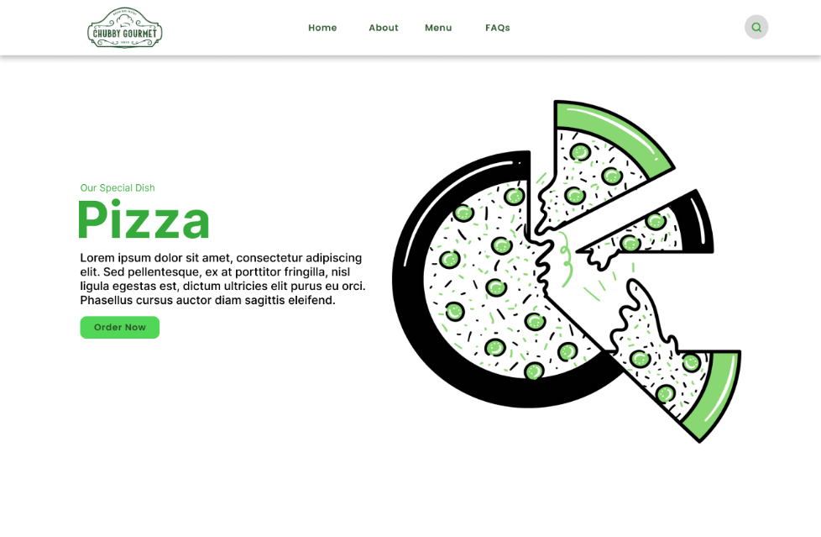

Fig. 53. Landing Page

Fig. 53 shows the landing page of E-Commerce Web Application. It contains the navigation bar and a call-to-action (CTA) button for the customer.

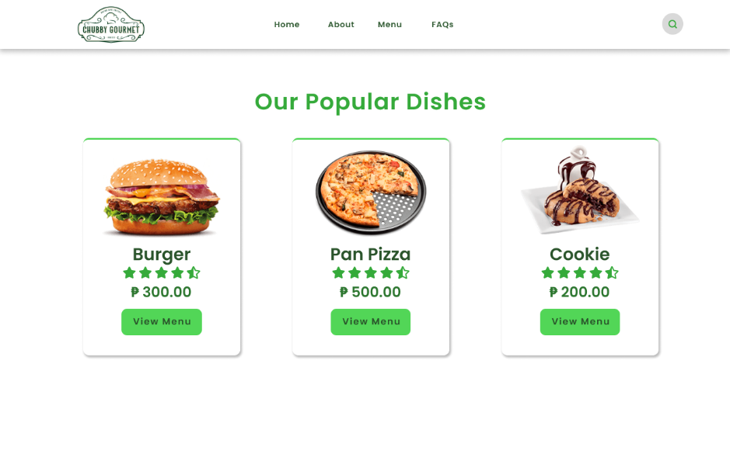

Fig. 54. Popular Dishes Section

Fig. 54 shows the popular dishes section of the system. It is where the system will automatically show that top-selling products of Chubby Gourmet based on their number of orders.

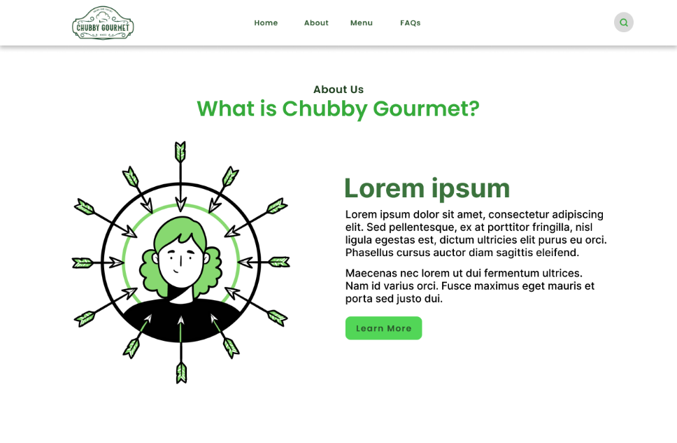

Fig. 55. About Section

Fig. 55 shows the about section where Chubby Gourmet can tell their history and what the business is all about to the customers.

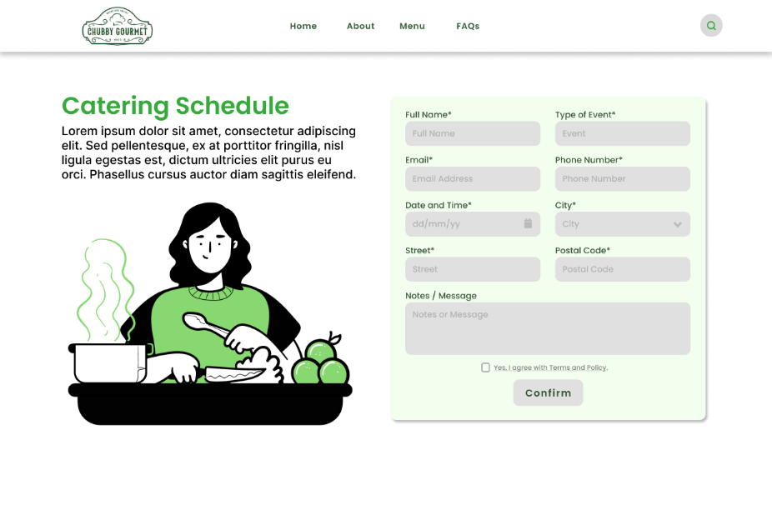

Fig. 56. Catering Schedule Section

Fig. 56 shows the newly added service of Chubby Gourmet. Catering schedule section contains the form where customers can fill-in as the first step in scheduling a catering service with Chubby Gourmet.

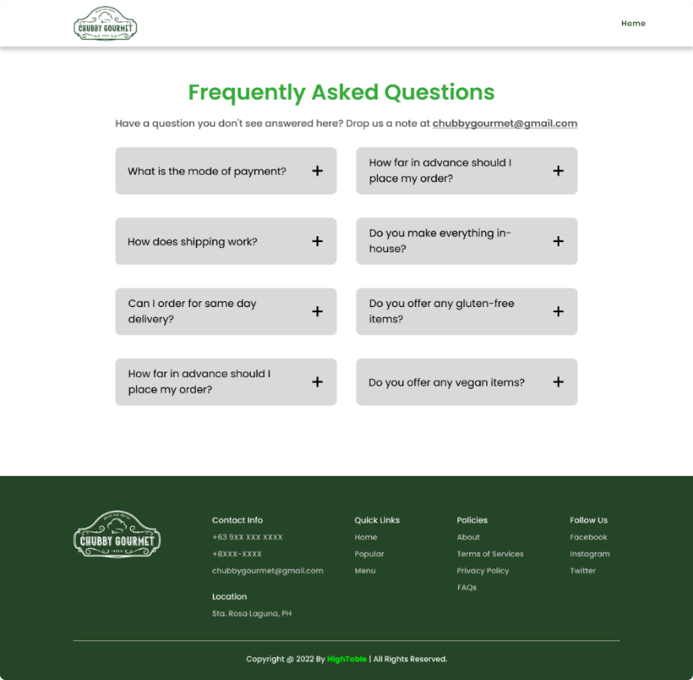

Fig. 57. Frequently Asked Questions Page

Fig. 57 shows the Frequently Asked Questions page to help the customers answer their queries within 2-3 clicks. In addition, Chubby Gourmet can manage the questions through the admin dashboard.

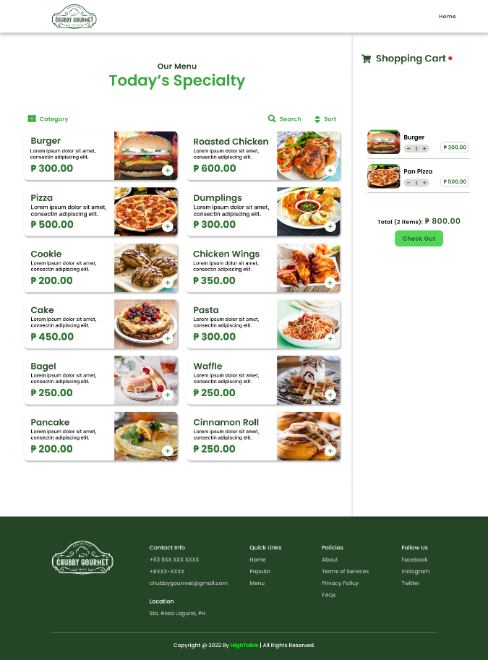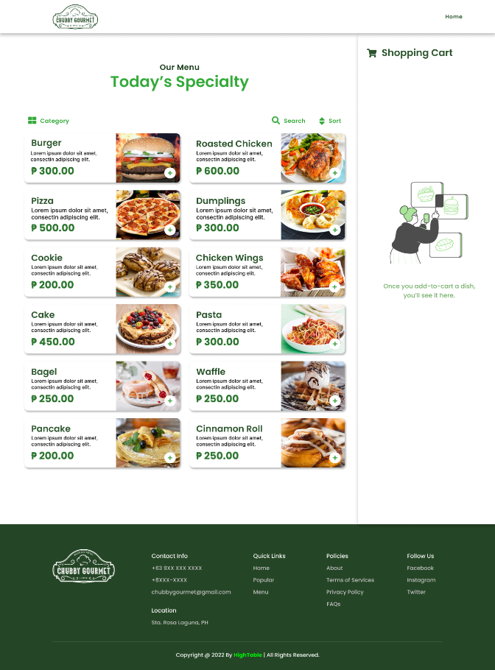

Fig. 58. Menu and Cart Page

Fig. 58 shows the menu page and the shopping cart of the system. It was designed for the customer to have an easy access to their cart just like when buying an item in a grocery store. Moreover, the products can be viewed easily based on their category.

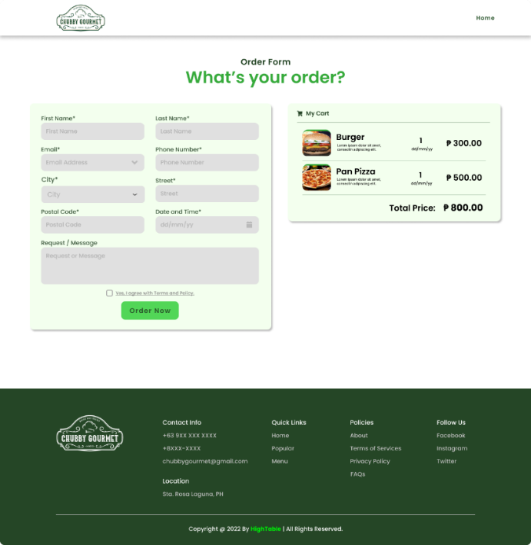

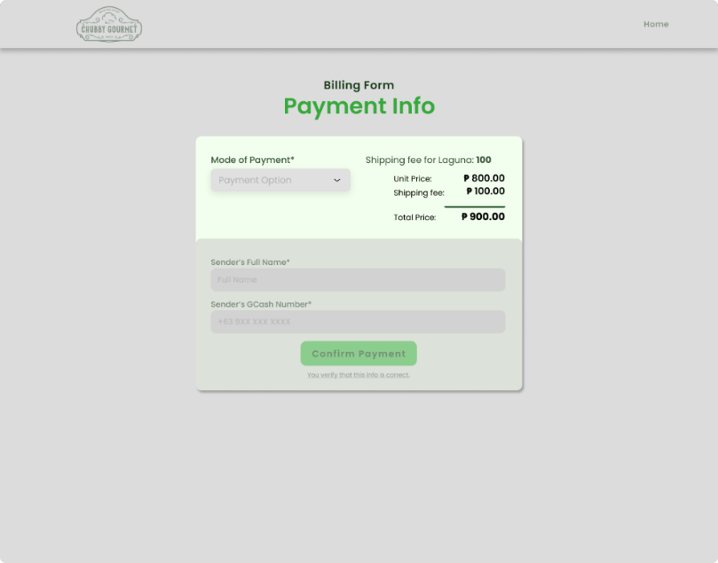

Fig. 59. Order and Payment form

Fig. 59 shows the order form and the payment form that the customer will fill-in to complete their order. It is a well-thought order form by the developers to answer the absence of account management for the customer. Moreover, due to limited area of delivery, the customer will choose whether they are from Laguna or Metro Manila. With this, the system will automatically add the delivery fee to the total amount that the customer will pay. The system can accept payments through PayPal or through displaying the GCash account information of Chubby Gourmet.

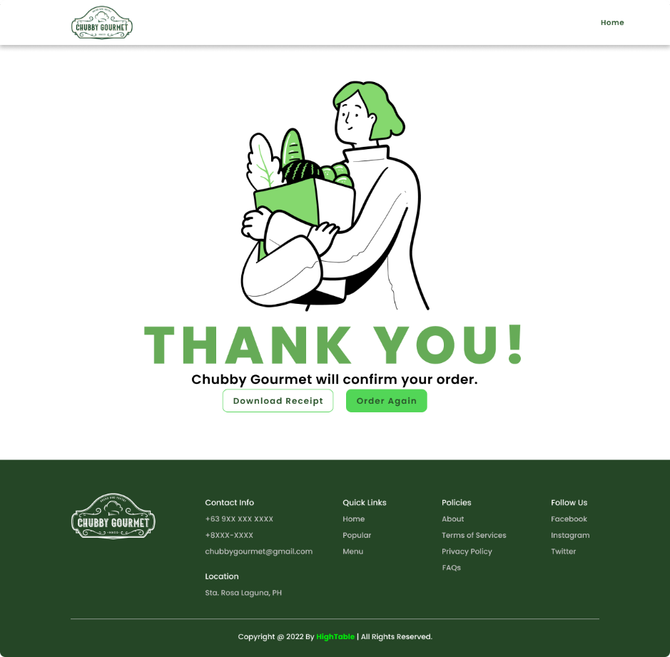

Fig. 60. “Thank you” page

Fig. 60 shows the success order page when the customer pays for their order. They will have the privilege to download their order form and order again.

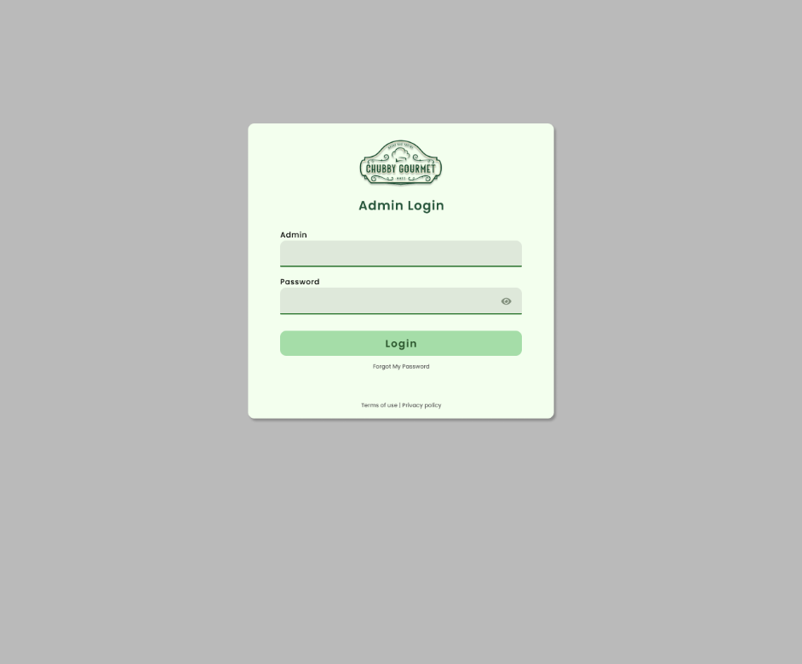

Fig. 61. Admin Dashboard Login

Fig. 61 shows the login screen of the admin dashboard. For security, Chubby Gourmet is required to input their credentials to access the dashboard.

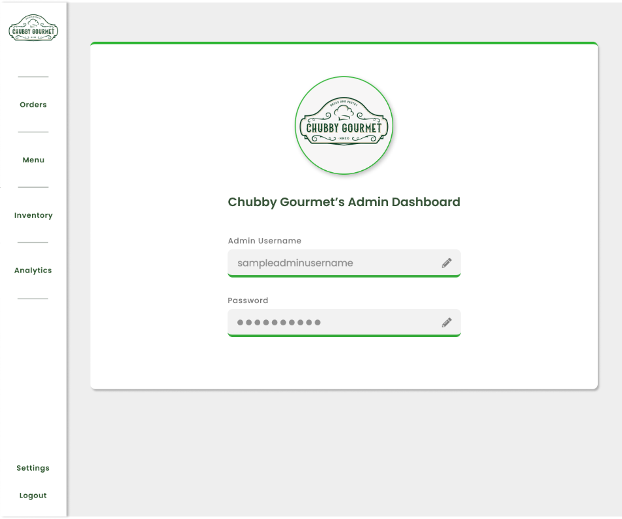

Fig. 62. Account Management Page

Fig. 62 shows the privilege of Chubby Gourmet to manage their account if they wish to change their credentials.

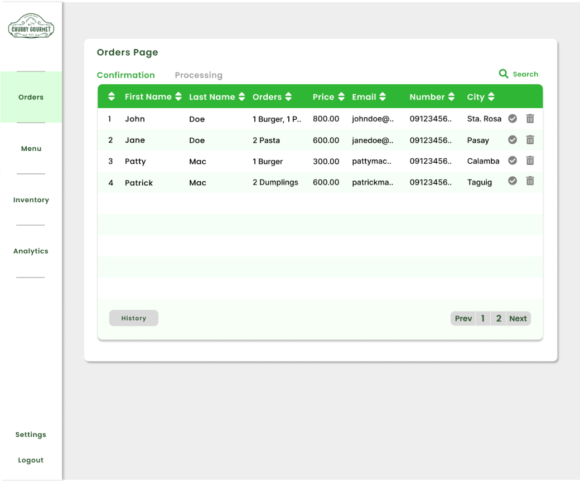

Fig. 63. Order Management Page

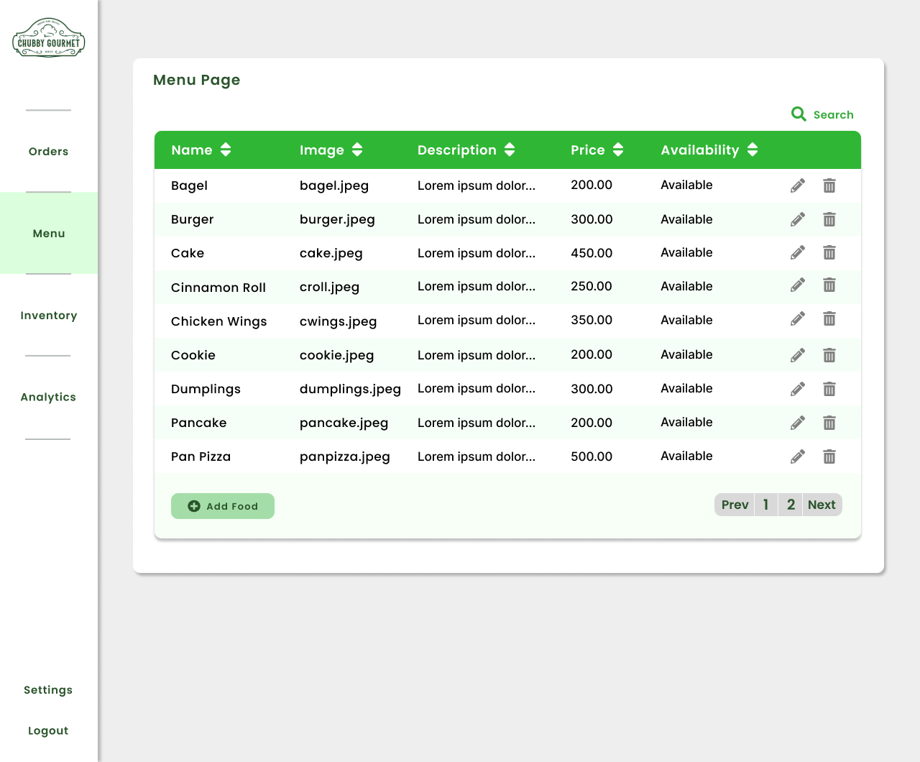

Fig. 64. Product Management Page

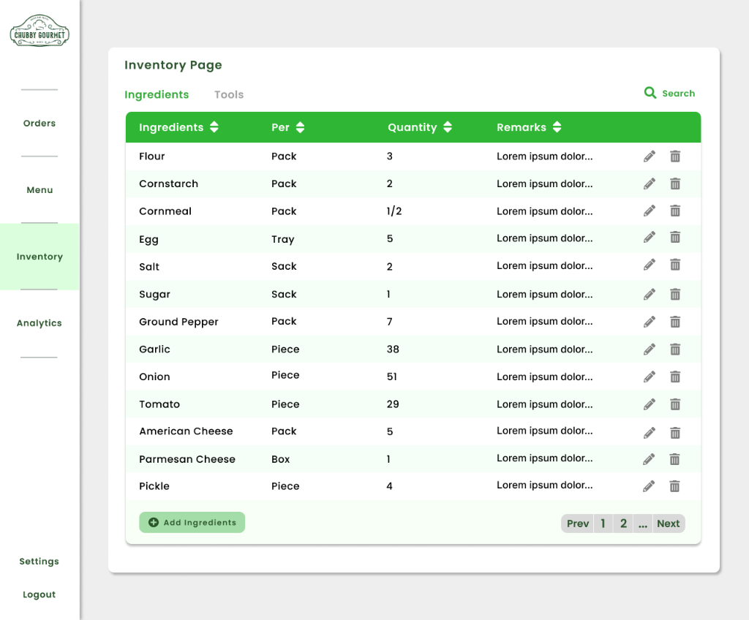

Fig. 65. Inventory Management Page

Fig. 63 through Fig. 65 shows the order, product, and inventory management pages where Chubby Gourmet can use to manage each business process. Features such as sorting, search, and modification are provided to access the items easily.

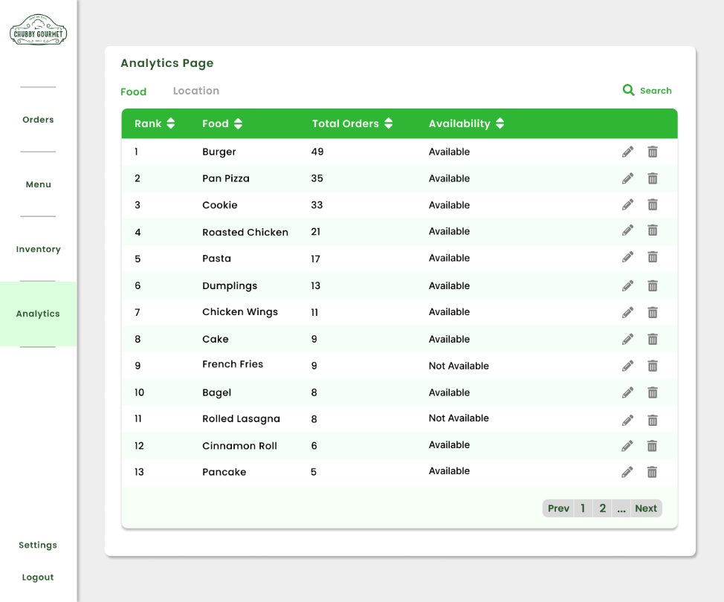

Fig. 66. Analytics Page

Fig. 66 shows the analytics page of the admin dashboard where Chubby Gourmet can see the top-selling product and the sales report of the business. Chubby Gourmet can print the report if they wish to.

## 5.3 Use Classes and Characteristics

Table IX enumerates the roles and descriptions of each user to make a successful order processing using the proposed system.

TABLE XVI   
USER CLASSES AND CHARACTERISITCS

|  |  |
| --- | --- |
| Roles | Description |
| Customer | This user interacts with the web application by ordering a product or just by checking out the business. When the customer orders a product, Chubby Gourmet proceeds to fulfill the order. |
| Chubby Gourmet | This user is the owner of the business and manages the order of the customer. This user also organizes the products by adding, deleting, and updating them. This user should know all the features of the web application for it to meet the objectives. |

# Conclusion

After taking into consideration the panelists, project advisor, and PBL instructor, the developers updated the proposal paper with even more intricate details. The developers were able to achieve a greater understanding of what the client needs, researched even further other similar e-commerce web applications and how certain features can be integrated into the proposed web application, designed diagrams that can help in creating the systems of the proposed web application, and has even drafted a prototype of the proposed web application. The developers were able to polish down uncertainties of what features they would wish to develop with their newly acquired knowledge and noted down what features they could develop with a bit of assistance from their consultant and the recommendations given by Chubby Gourmet. The developers are currently waiting to let their newly added diagrams and methodologies to be approved by the panelists and will proceed to develop the app beyond the prototype once their proposal is finally approved.

# References

|  |  |
| --- | --- |
| [1] | C. Gourmet, "Facebook," [Online]. Available: https://www.facebook.com/chubbygourmet. |
| [2] | D. o. T. a. I. (DTI), "2020 MSME STATISTICS," [Online]. Available: https://www.dti.gov.ph/resources/msme-statistics/#:~:text=Number%20of%20Establishments,enterprises%20operating%20in%20the%20country. |
| [3] | Ong, Cleofas, Prasetyo, Chuenyindee, Young, Diaz, Nadlifatin and Redi, "Consumer Behavior in Clothing Industry and Its Relationship with Open Innovation Dynamics during the COVID-19 Pandemic," 2021. [Online]. Available: https://www.mdpi.com/1303070. |
| [4] | Abuhashesh, "Integration of Social Media in Businesses," 2014. [Online]. Available: https://www.researchgate.net/publication/332466527_Integration_of_Social_Media_in_Businesses. |
| [5] | Esker, "Addressing Manual Order Management in an SAP Environment," [Online]. Available: https://cloud.esker.com/fm/others/001_Esker_eBook_F2O_SAP-US.pdf. |
| [6] | Atieh, Kaylani, Al-abdallat, Qaderi, Ghoul, Jaradat and Hdairis, "Performance Improvement of Inventory Management System Processes by an Automated Warehouse Management System," [Online]. Available: https://www.sciencedirect.com/science/article/pii/S2212827115012019. |
| [7] | T. D. Knead, "The Daily Knead," [Online]. Available: https://www.thedailyknead.com.ph/?gclid=CjwKCAjwjZmTBhB4EiwAynRmD0qvA-NRXyeUwFz5hYxc_UzyOIZgqZXZHdzZbAkWapyNmV6vjoDoKRoCwcAQAvD_BwE. |
| [8] | A. Khan, "Electronic Commerce: A Study on Benefits and Challenges in," 2016. [Online]. Available: https://globaljournals.org/GJMBR_Volume16/3-Electronic-Commerce-A-Study.pdf. |
| [9] | A. Sonnenberg, "How You Can Measure Return on Investment for Ecommerce," 2022. [Online]. Available: https://www.agorapulse.com/blog/ecommerce-roi/#:~:text=successful%20advertising%20campaigns.-,What%20Is%20Ecommerce%20ROI%3F,can%20be%20positive%20or%20negative.. |
| [10] | D. Magpantay, Interviewee, *cpa.* [Interview]. 2022. |
| [11] | "GoDaddy," [Online]. Available: www.godaddy.com. |
| [12] | "Hostinger," [Online]. Available: www.hostinger.ph. |
| [13] | Vilaca, "Diving deeper in E-commerce: Guest checkout vs Customer accounts," 2018. [Online]. Available: https://wearemonday.medium.com/diving-deeper-in-e-commerce-guest-checkout-vs-customer-accounts-c35e4bbd0d68. |
| [14] | C. Moriones, "Casa Moriones," [Online]. Available: https://casamorionescatering.ph/. |
| [15] | J. &. Pat's, "Jess & Pat's," [Online]. Available: https://jessandpats.com/. |
| [16] | G. Food, "Grab Food," [Online]. Available: https://food.grab.com/ph/en/?gclid=CjwKCAjw9qiTBhBbEiwAp-GE0URh0uyh8K5OeYs4wUyff1nqUxNbm_8-gbISG83xKXAYU_Kz71xb_xoCjNEQAvD_BwE&gclsrc=aw.ds. |
| [17] | F. Panda, "Food Panda," [Online]. Available: https://www.foodpanda.ph/?gclid=CjwKCAjw9qiTBhBbEiwAp-GE0ZUaxMjdgayTBkXfmfIKV7_ot70I5zkjrJLpt6QWKlU2s3xRVk-uGRoCNE4QAvD_BwE. |
| [18] | Microsoft, "Microsoft Docs," Microsoft, [Online]. Available: https://docs.microsoft.com/en-us/power-platform/admin/web-application-requirements. |
| [19] | S. Tilley, Systems Analysis and Design. 12th Edition, Cengage Learning, 2020. |

# Appendices

## Appendix A: Project Vision

TABLE XVII   
PROJECT VISION

|  |  |  |
| --- | --- | --- |
|  | Customer | Chubby Gourmet |
| FOR | Customers that crave food | The owner of Chubby Gourmet |
| WHO | Want to order food efficiently | Endures manual writing down of order information that takes a lot of time |
| THE | Chubby Gourmet’s E-commerce Web Application | |
| IS A | Web Application | |
| THAT | Will help the customers choose their meal efficiently by providing the popular dish of the week, | Will provide an admin dashboard for the owner to have an organized list of order information instantly, |
| UNLIKE | Enduring the inconvenience of scrolling through the Facebook page of the business to check and order products, and copying and pasting order forms that need to be filled in. | Manually write the order information of customers on a whiteboard that will eventually be erased after processing the order. |
| OUR PRODUCT | Will also eliminate the need to copy and paste every order form and encourage customers to get notifications about announcements such as new products and discounts. | Will also digitize 100% of the inventory management of Chubby Gourmet and rank the dishes based on their demand to help the business adjust its marketing strategy. |

## Appendix B: Product Roadmap

TABLE XVIII  
PRODUCT ROADMAP

|  |  |  |  |  |
| --- | --- | --- | --- | --- |
|  | MNTSDEV | MSYADD1 | MCSPROJ | |
| Ordering Web Application | * Mock-up design | * System Analysis and Diagrams | * Login to Store * View Products * Create Order * Track Order | |
| Admin Dashboard |  |  | | * Login to Admin Dashboard * Manage Product * Manage Order * Manage Inventory * Generate Report |

## Appendix C: Teams Meeting

**Meeting with Adviser**

September 13, 2022



**Meeting with Client**

September 7, 2022

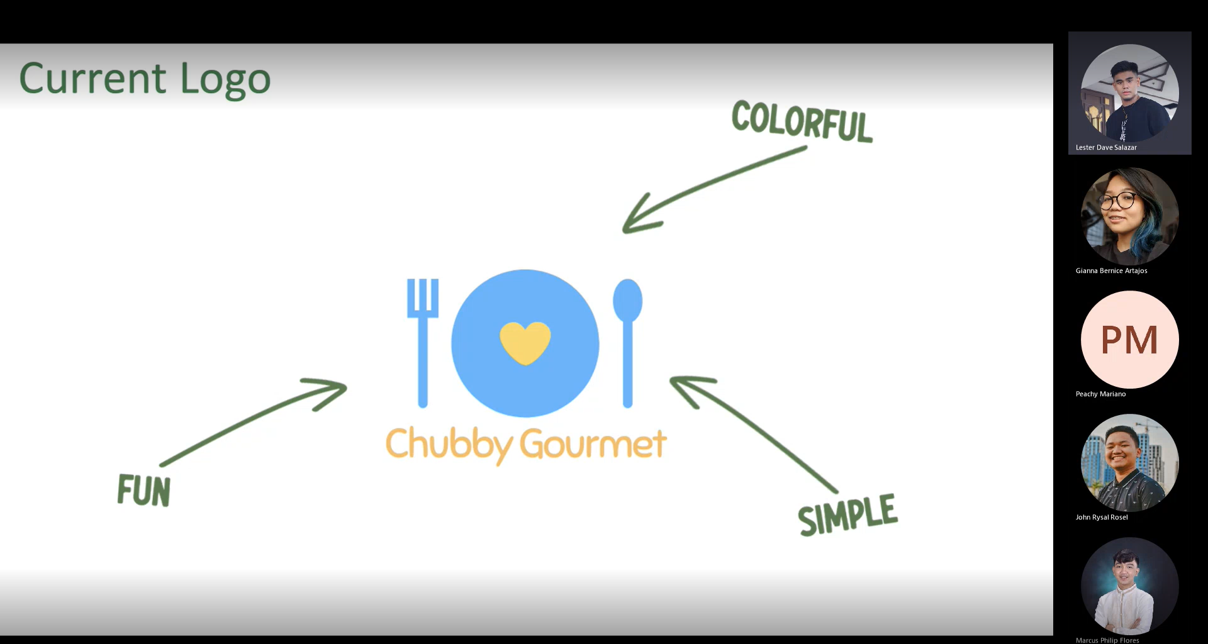

## Appendix D: Minutes of the Meeting

**DATE:** 09/07/2022

**TIME:** 3:00 pm – 4:00 pm

**WHERE:** Microsoft Teams

**TYPE OF MEETING:** Decision Making

**FACCILITATOR:** Gianna Bernice Artajos

**MINUTE TAKER:** Marcus Flores

**PRESENT ATTENDEES**

|  |  |
| --- | --- |
| Gianna Bernice Artajos | **Student** |
| Marcus Philip Flores |
| John Rysal Rosel |
| Lester Dave Salazar |
| Ms. Peachy Mariano | **Client** |

**AGENDA TOPICS:**

* update
* logo approval
* web design approval
* payment of customers
* plans

**ALLOCATED TIME:** 1 hour

**DISCUSSION:** Discussion with the plans for the system and presentation of product design.

**CONCLUSION:** The client directed what should be added or done to the website and logo.

|  |  |
| --- | --- |
| **ACTIONS** | **ACTIONS TO BE TAKEN BY** |
| Provide variations of logo | Lester Dave Salazar |
|  |  |
|  |  |
|  |  |

**DATE:** 09/13/2022

**TIME:** 11:00 am – 12:00 nn

**WHERE:** Microsoft Teams

**TYPE OF MEETING:** Presentation of updates

**FACCILITATOR:** Gianna Bernice Artajos

**MINUTE TAKER:** Marcus Philip Flores

**PRESENT ATTENDEES**

|  |  |
| --- | --- |
| Gianna Bernice Artajos | **Student** |
| Marcus Philip Flores |
| John Rysal Rosel |
| Lester Dave Salazar |
| Ms. Jo Anne M. de la Cuesta | **Adviser** |

**AGENDA TOPICS:**

* client update reports
* questions about diagrams in MSYADD1
* plans

**ALLOCATED TIME:** 1 hour

**DISCUSSION:** Discussion about the input of the client and what we will do about the diagrams and plans.

**CONCLUSION:** Adviser answered all the questions asked and help us for the plans and parts in the paper.

|  |  |
| --- | --- |
| **ACTIONS** | **ACTIONS TO BE TAKEN BY** |
| Editing of Event Table | Gianna Bernice Artajos |
| Editing of ERD | Marcus Philip Flores |
| Editing of DFD | John Rysal Rosel |
| Editing of Use Case Diagram | Lester Dave Salazar |

**DATE:** 09/18/2022

**TIME:** 11:00 am – 12:00 nn

**WHERE:** Discussion Room A – 7th floor

**TYPE OF MEETING:** Presentation of updates

**FACCILITATOR:** Gianna Bernice Artajos

**MINUTE TAKER:** John Rysal Rosel

**PRESENT ATTENDEES**

|  |  |
| --- | --- |
| Gianna Bernice Artajos | **Student** |
| John Rysal Rosel |
| Lester Dave Salazar |
| Ms. Jo Anne M. de la Cuesta | **Adviser** |

**AGENDA TOPICS:**

* Presentation of diagram
* Update about midterm paper
* Progress Report

**ALLOCATED TIME:** 1 hour

**DISCUSSION:** Discussion about the paper and evaluation of the diagram.

**CONCLUSION:** Adviser answered all the questions asked and checked all the diagrams and parts of the paper.

|  |  |
| --- | --- |
| **ACTIONS** | **ACTIONS TO BE TAKEN BY** |
| Presentations of diagrams | HighTable |
| Comments matrix | Gianna Bernice Artajos |
| Checking of papers | All |